Central Zoo Authority

USER MANUAL
(Getting Started With CZA)

Statutory Body of the Ministry of Environment, Forest and Climate Change, Government of India
CONTENTS
1. Introduction 3
2. Login as Zoo Admin/Zoo User 3
3. Animal Inventory 6
3.1 Animal Inventory Form 6
3.2 View 14
3.3 Submit to CZA 14
3.4 Create Animal History Card 15
3.4.1 Animal History Card 16
3.4.2 Admission of rescued animals 17
3.4.3 Mortality Report 18
4. Apply-Renewal Form 21
5. Assign for Evaluation 26
6. Master Plan 31
7. Enclosure Drawing 35
8. Exchange of Animals 38
9. Zoo Activity 41
10. Zoo Information 42
11. Add Revenue and Expenditure 46
12. User Management 46
13. Establishment Form 48

Introduction
The Central Zoo Authority's mission is to provide better upkeep and veterinary care to the wild animals housed in zoos in India to ensure their conservation through best practices of management and bringing education & awareness among the people.
Central Zoo Authority intends to Design & Develop the Web application for the Department (ZOO-MIS) which will help zoo and CZA to get reports from the zoos. Following are the features and operations that will be performed by this application.

Login as Zoo Admin/Zoo User
- To login as a Zoo Admin , open the URL: http://staging8.velocis.in:91/cza/login in the browser. Following screen will be displayed:

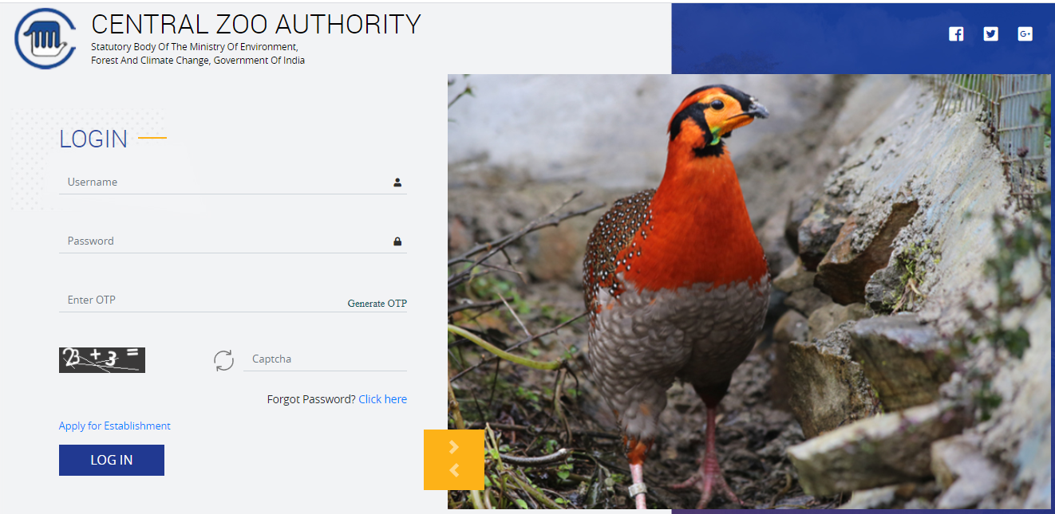

Users are mapped into the system with unique id and password. Steps to access the web application
- Enter Username
- Enter Password
- Click on Generate OTP link to generate the OTP, following popup will display

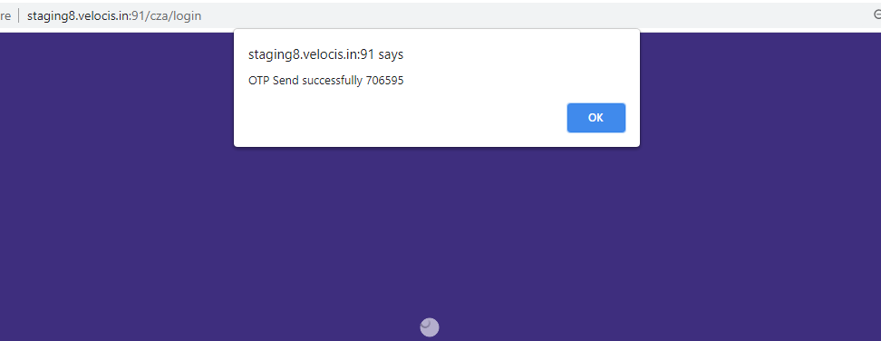

- An OTP will be sent to your registered mobile number" once the mobile sms function is integrated
- Enter Captcha Code
- Click on Login button
- After login, dashboard screen will appear as shown in screen below:

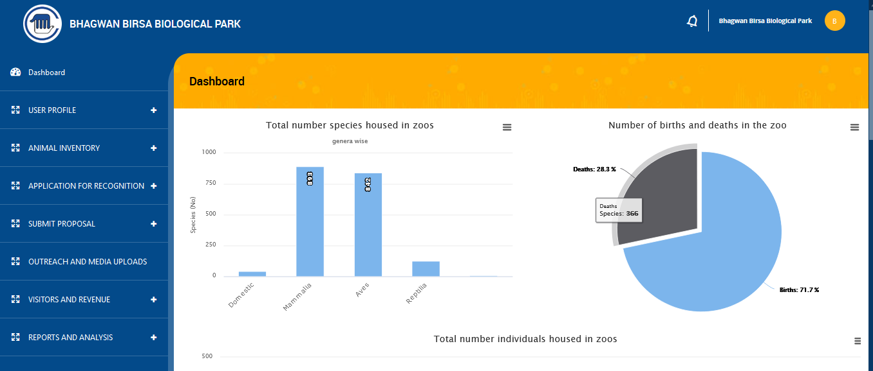
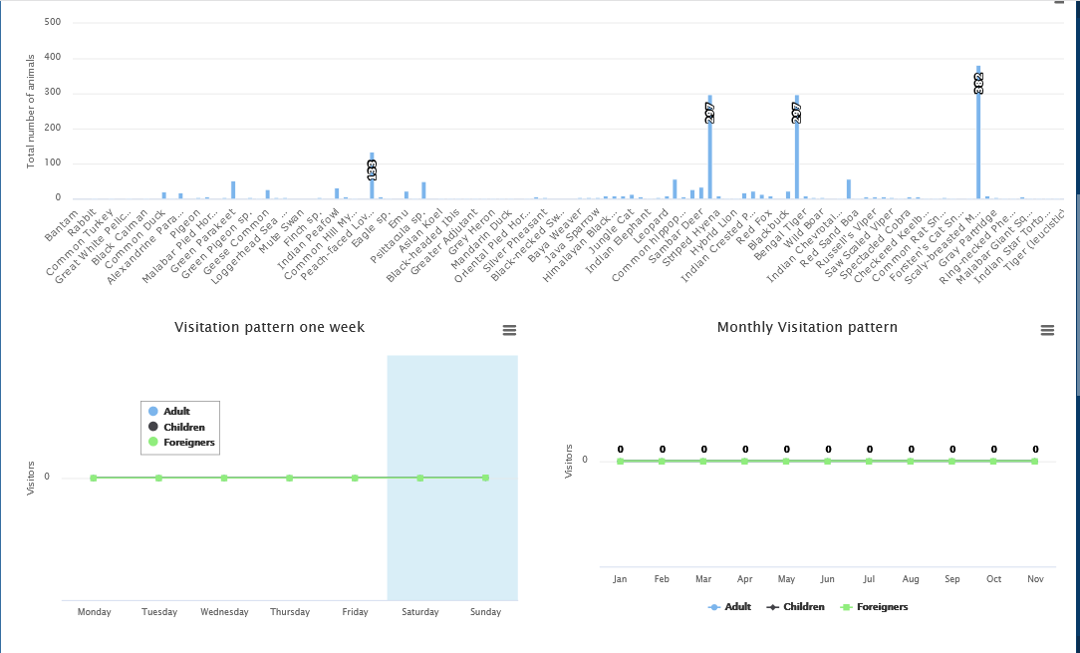
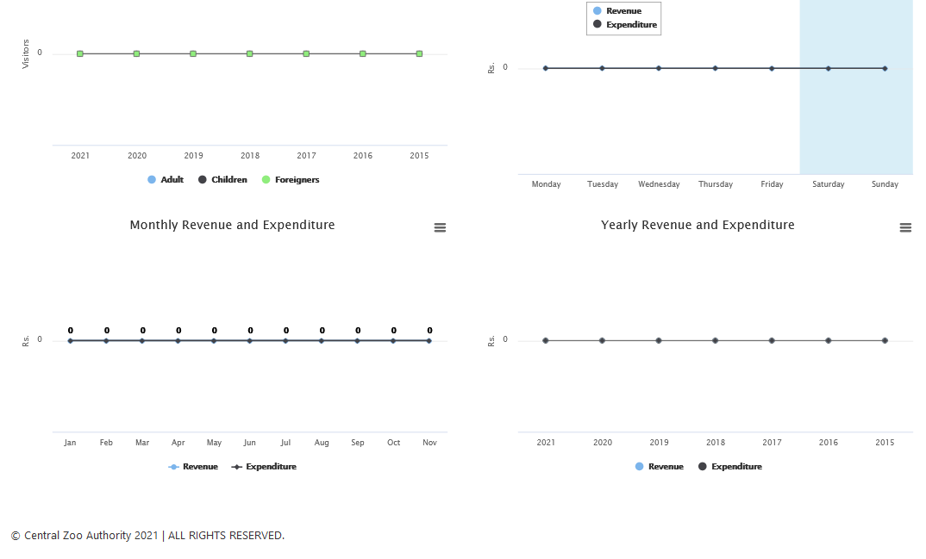

Note : Login process will remain same for Zoo User. Zoo Admin can create its Zoo User and give permissions as per the roles/requirements. Zoo User can see the only the menus for which they are given permission by their Zoo Admin. All the functionality will remain the same.

Animal Inventory
Zoo users will use this module for entering the inventory into the system on Quarterly/Annual basis and also update the database on a real-time basis (to add information pertaining to acquisitions, disposals, births, deaths etc.).

Animal Inventory Form

- Click on ‘ + ‘ sign to expand , following menus will display as shown below:

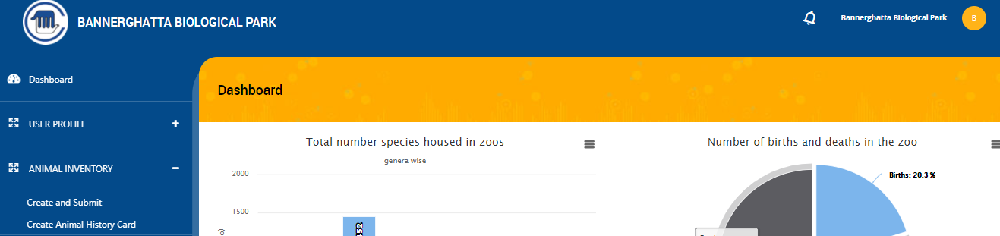

- On clicking on Create and Submit link , following screen will display as shown below:

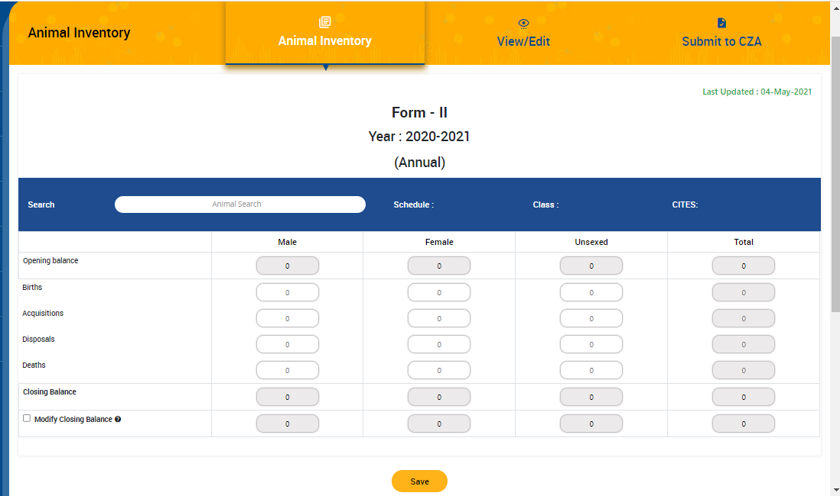
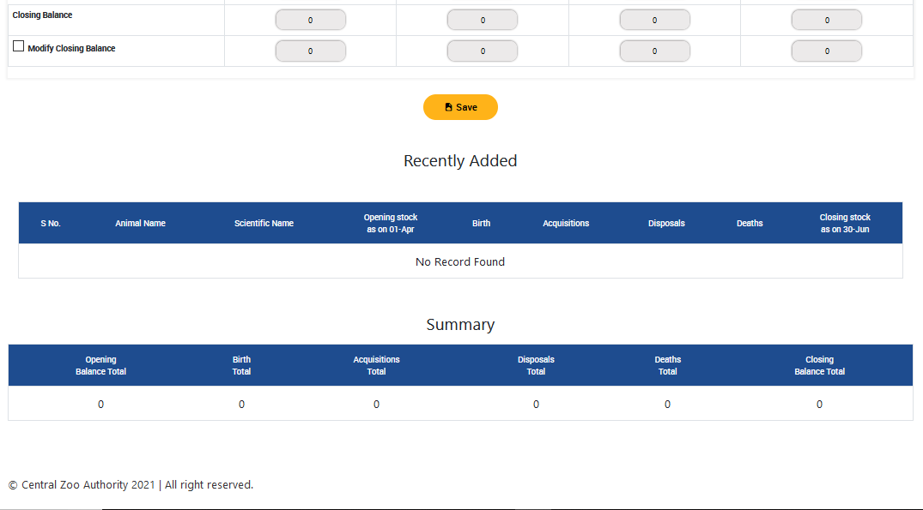
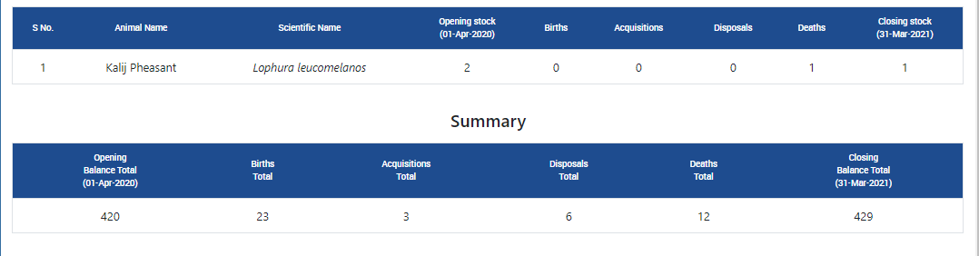

- Before entering animal details, search animal in search box as shown below:

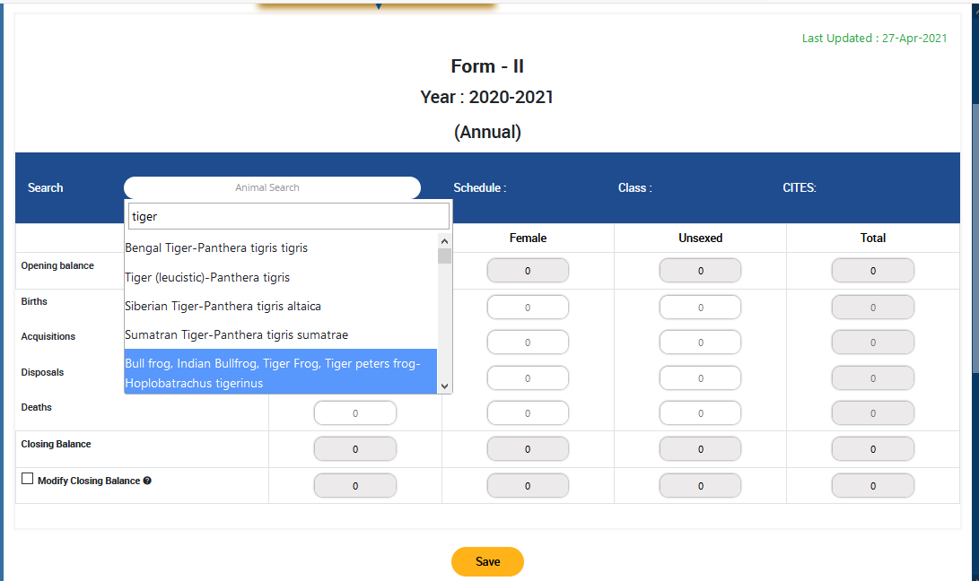

- Enter Birth details
- Enter Acquisitions details
- Enter Disposals and Deaths details
- If enter Disposals and Deaths data more than available Current stock then following popup gets open as shown below:

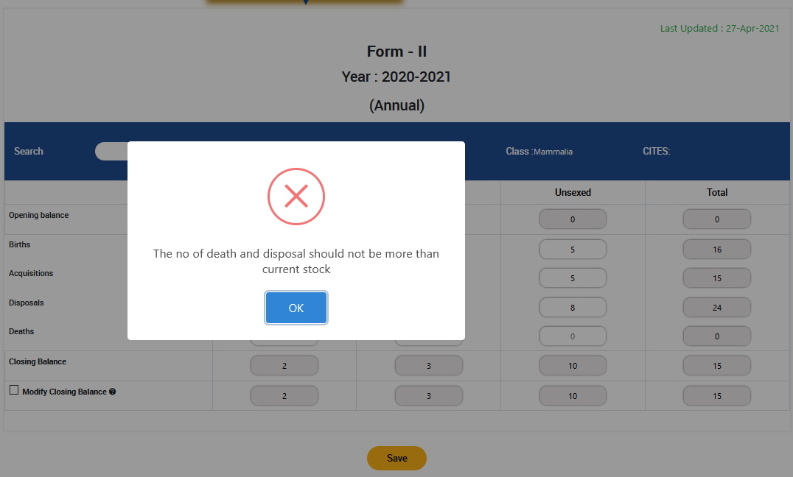

- If enter Deaths details then Add PM report link will get appear as shown below:

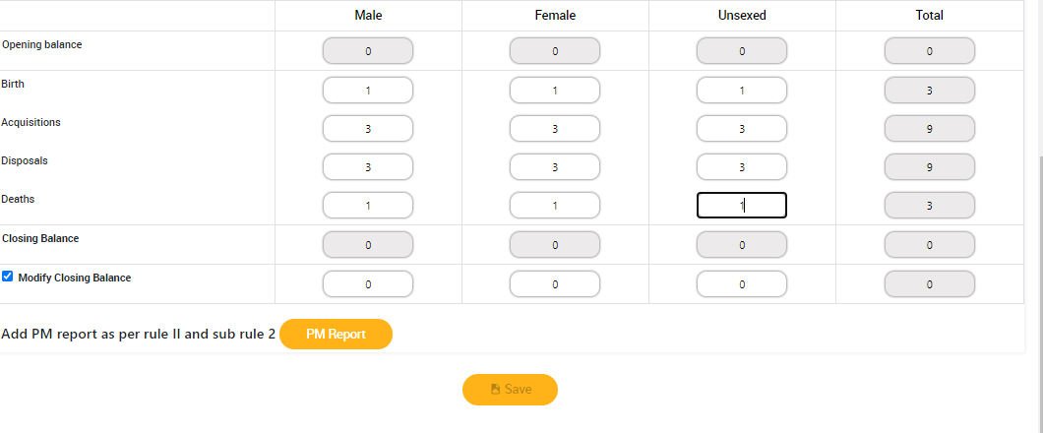

- Click on PM Report button to fill the Post Mortem Form will be displayed as shown in screen below:

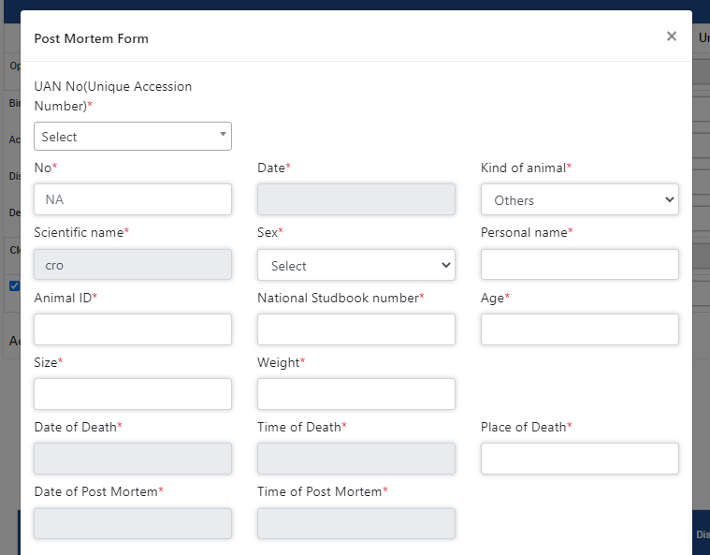
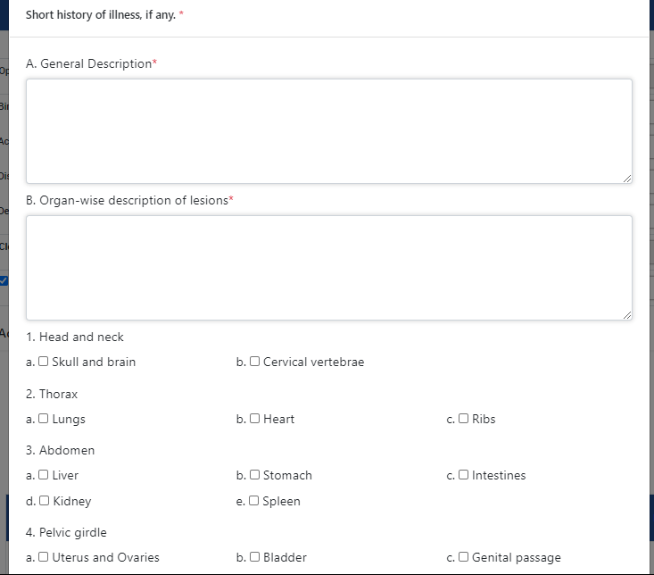
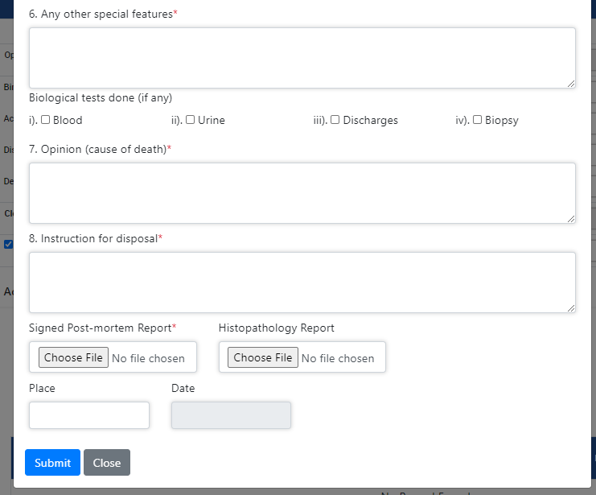

- Fill all details then submit the PM details
- If user wants to edit Closing details then click in ‘Modify Check Box ’ and click on Save button. Confirmation message popup will display as shown below:

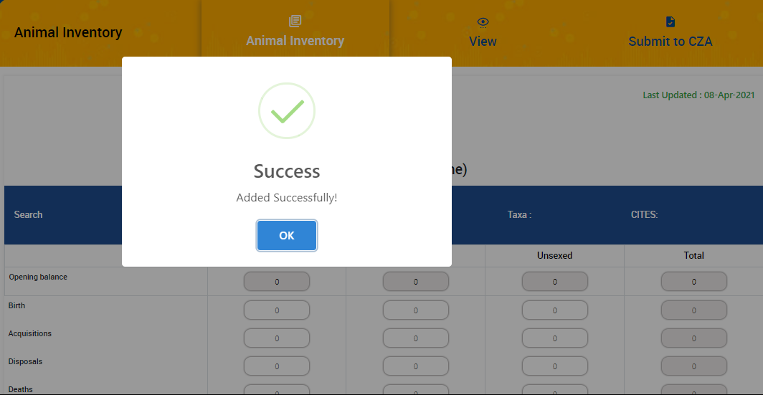

- Saved data will get saved in ‘Recently Added’ table and all data will get updated in Summary table as shown below:

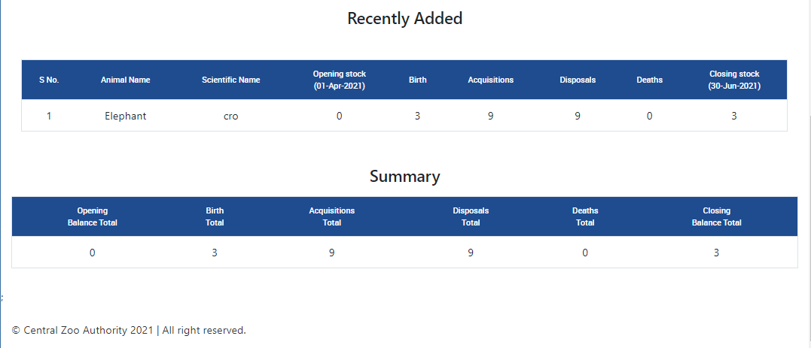

View
To view the data, click on ‘View’ link available on top of page, following screen will display as shown below:
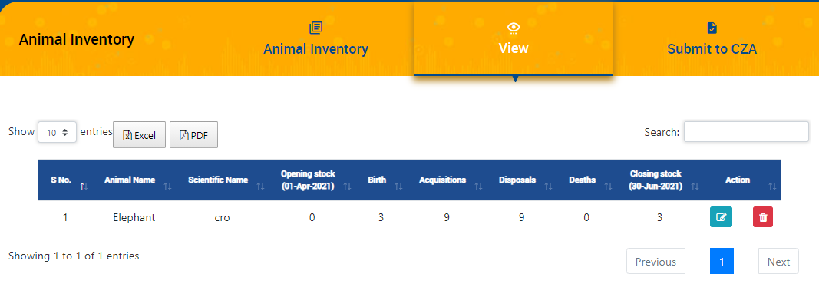

- User can Edit and Delete the data by clicking on Actions button as shown in above screen:
- Data can be downloaded in Excel and PDF formats by the link of the same as shown above.
- User can search data with the help of Search bar.

Submit to CZA
To submit data to CZA authority, click on ‘Submit to CZA’ link, following screen will display as shown below:

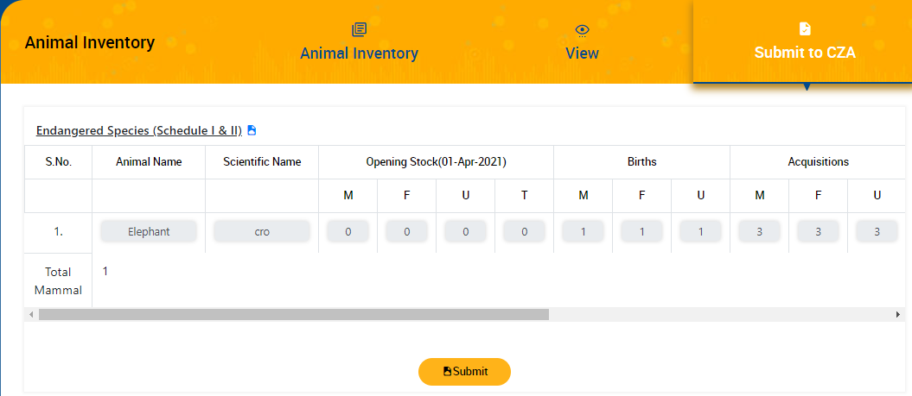

- After clicking on final submission, a confirmation message will be displayed as shown below:

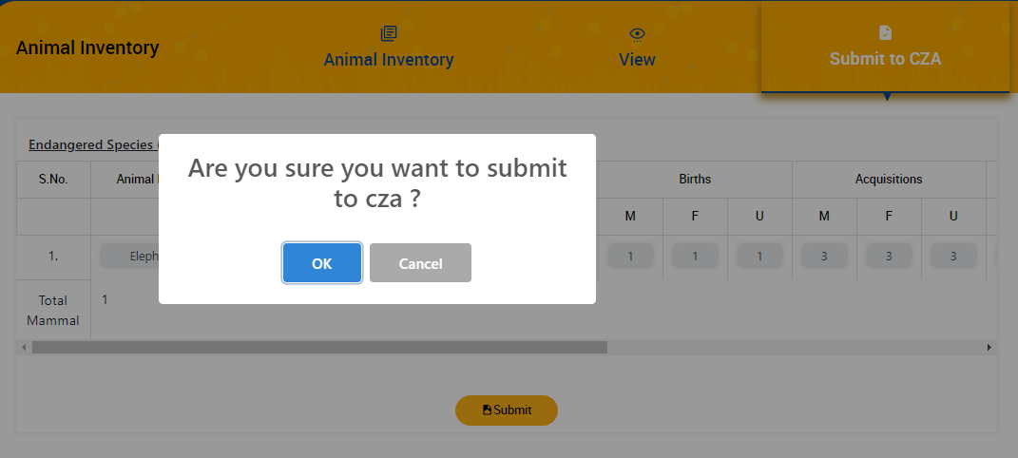

- Click on OK button to proceed
- A row will get appear for data submission of next quarter as shown in screen below:

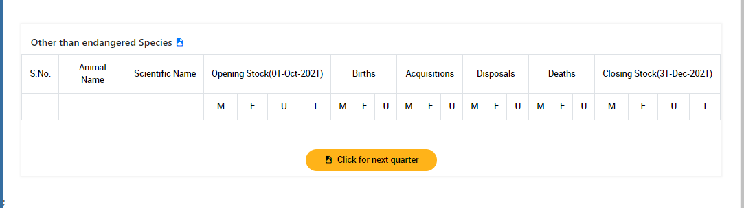

Create Animal History Card
Animal History Card is divided into five sub modules as shown in screen below:
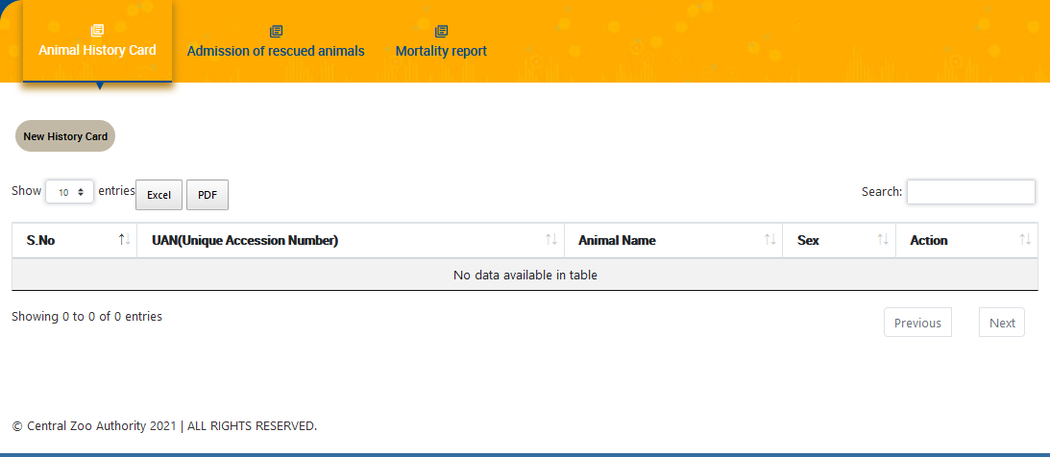

Animal History Card
To create new History Card of animal click on History Card button, following screen will be displayed as shown below:
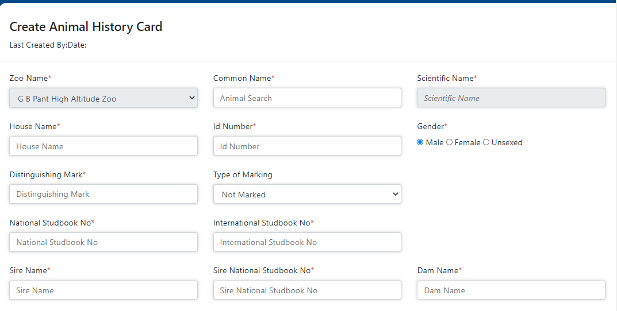
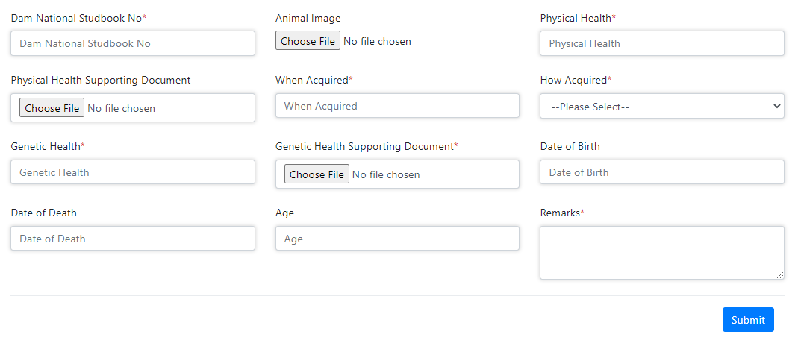

- Fill all details and click on submit button
- Unique ID will be generated after after save the information.

Admission of rescued animals
To fill rescue details of animal click on Rescue Form, following screen will be displayed as shown below:

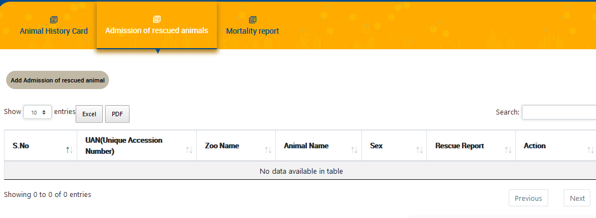

- Click on ‘Admission of rescued animals’ button , following screen will be displayed as shown below:

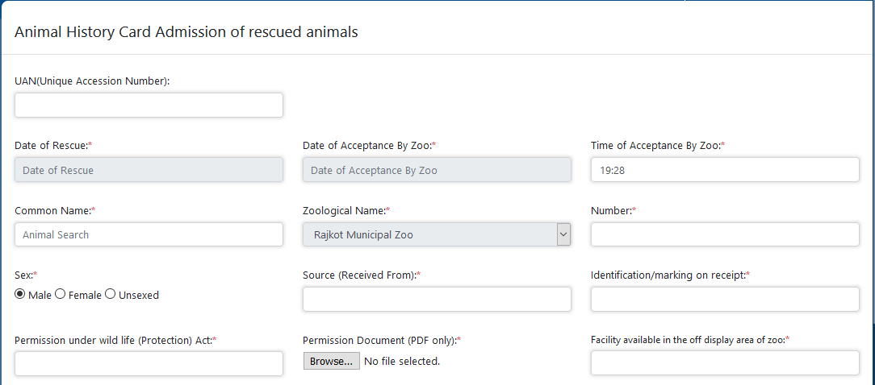

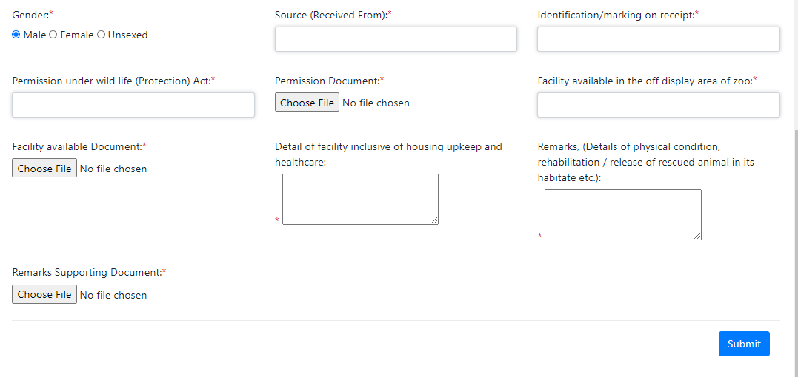

- Fill all details and click on Submit button

Mortality Report
To fill MR details of animal click on Mortality Report button, following screen will be displayed as shown below:

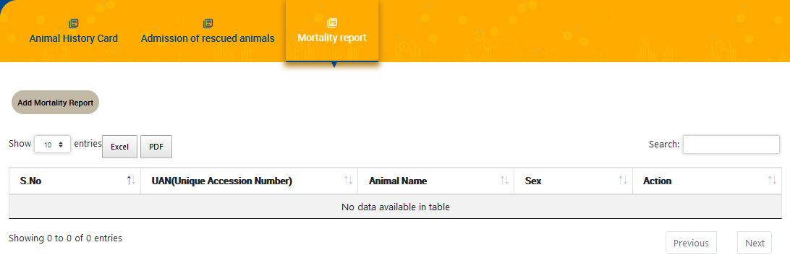

- Click on ‘Add Mortality Report’ button, following form will be displayed as shown in screen below:

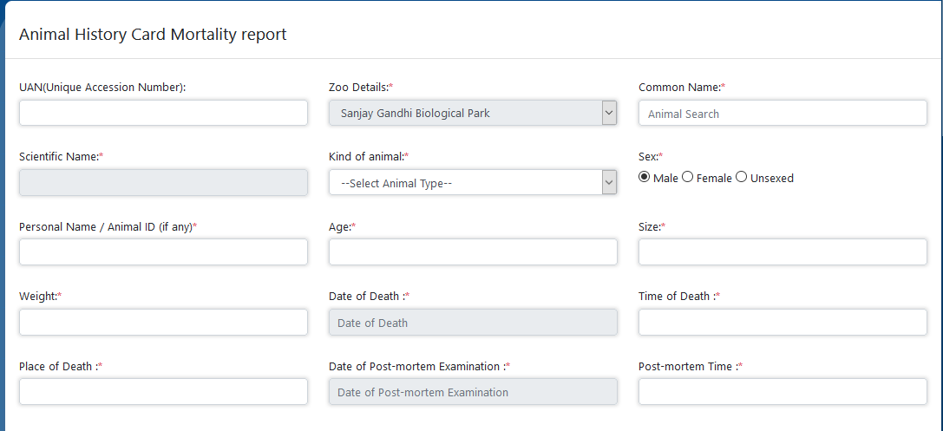
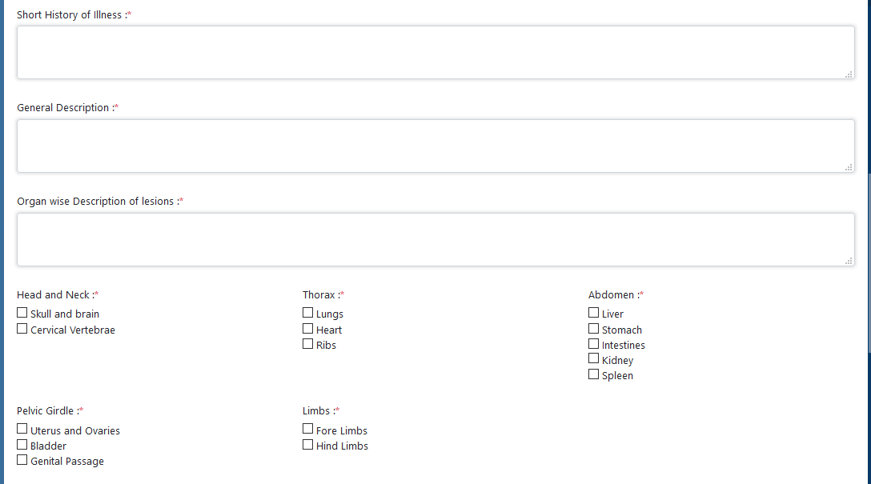
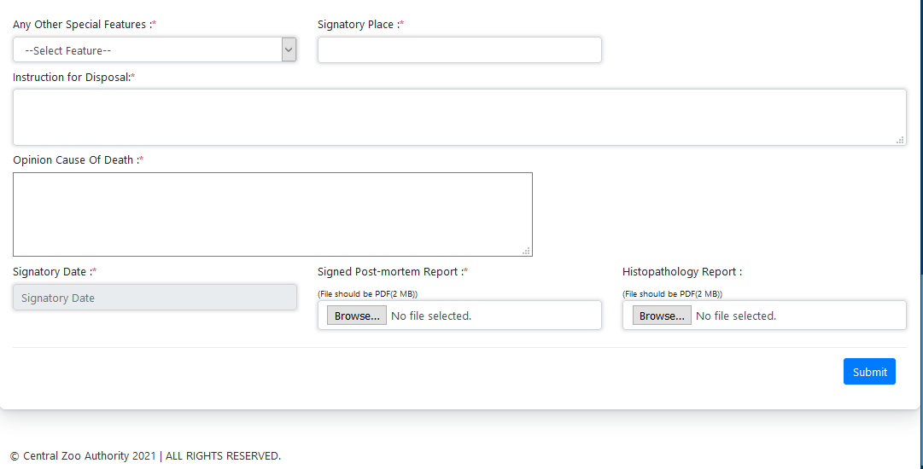

- Fill all required details then click on Submit button

Apply-Renewal Form
- Expand the Apply link from left navigation bar then click on Renewal Form. Following screen will display as shown in screen below:

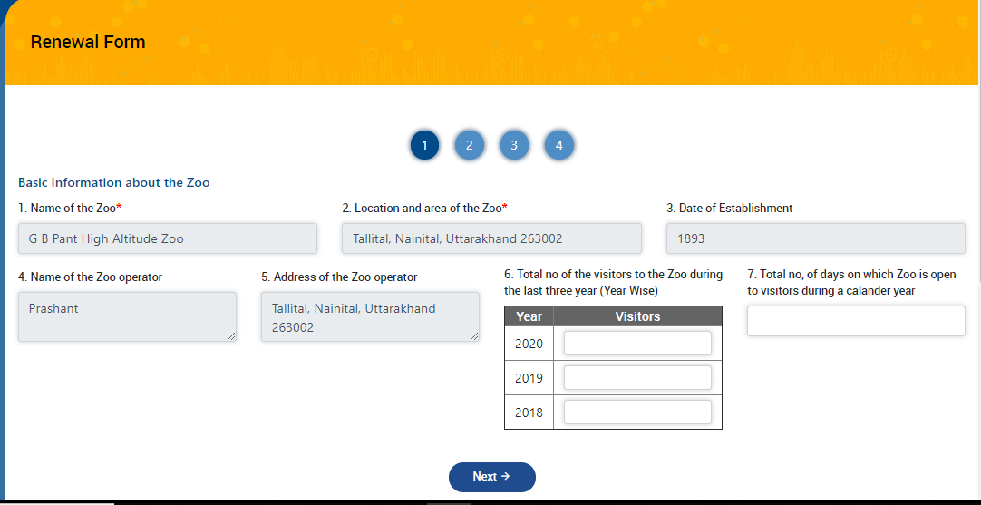

- Fill details in field no.6 and 7

- Click on Next button, confirmation popup will be displayed as shown below:

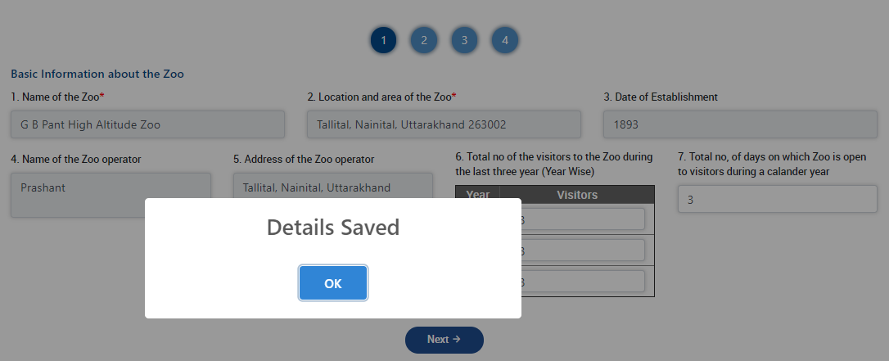
- After clicking on OK button, control will jump on next page as shown below:

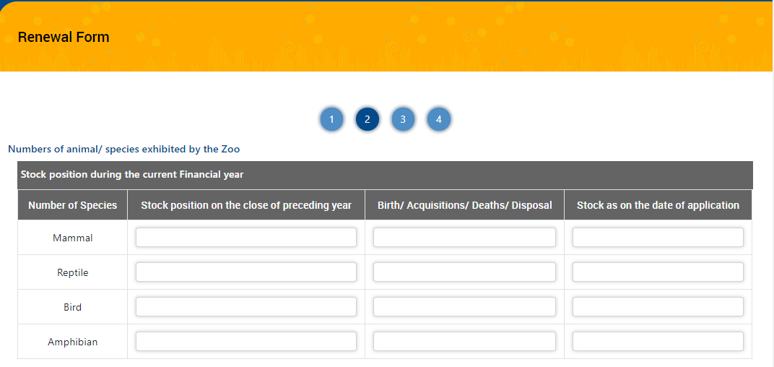
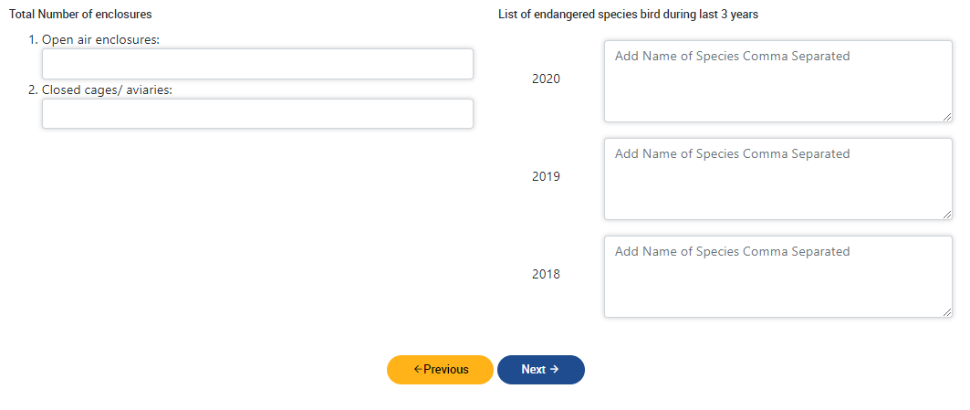

- Fill all required details and click on Next button. Control will jump on next page and following screen will display:

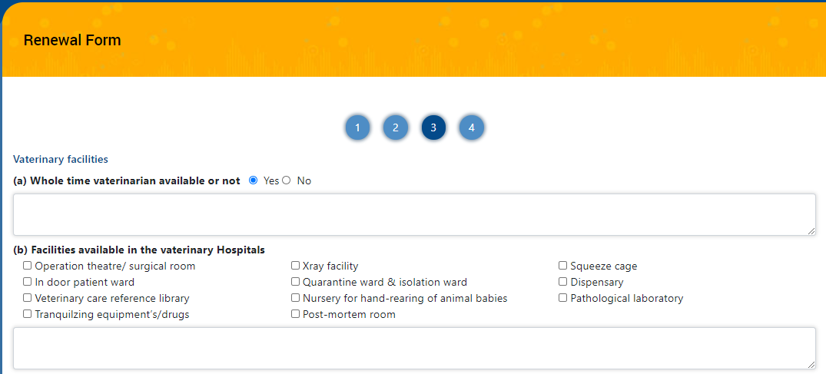

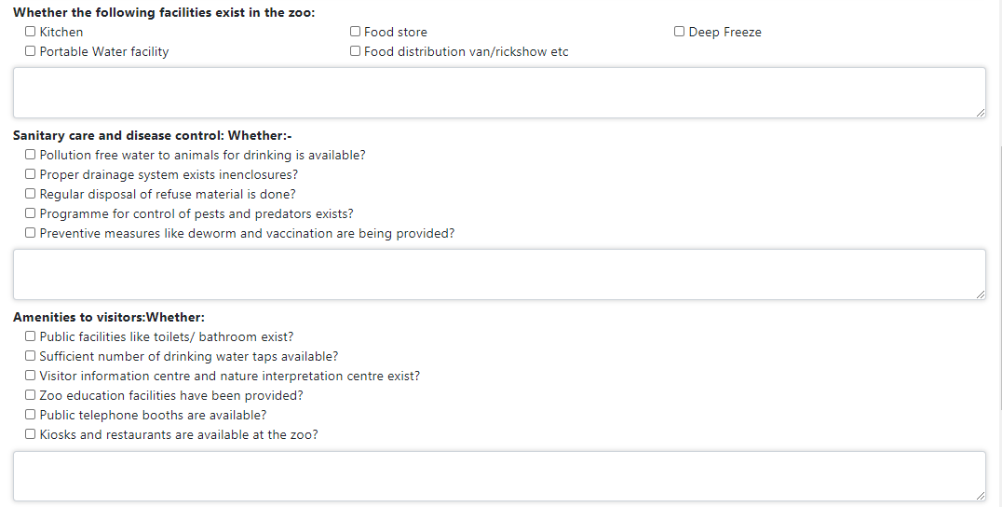
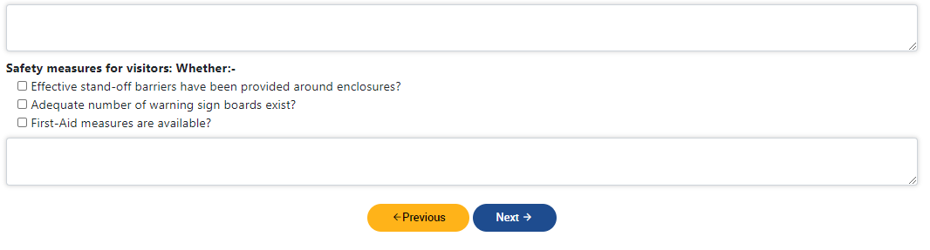

- Fill all required details and click on Next button. Control will jump on next page and following screen will display:

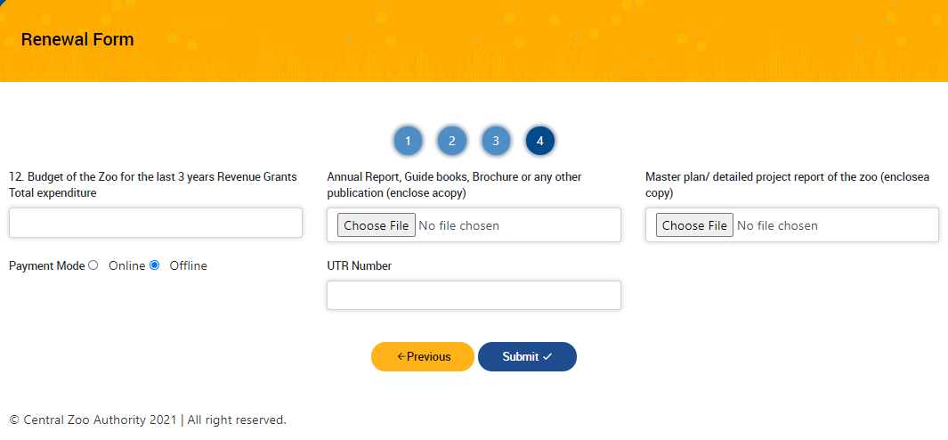
- Fill all required details and click on Submit button.
- Before final submission, an alert will generate as shown below:

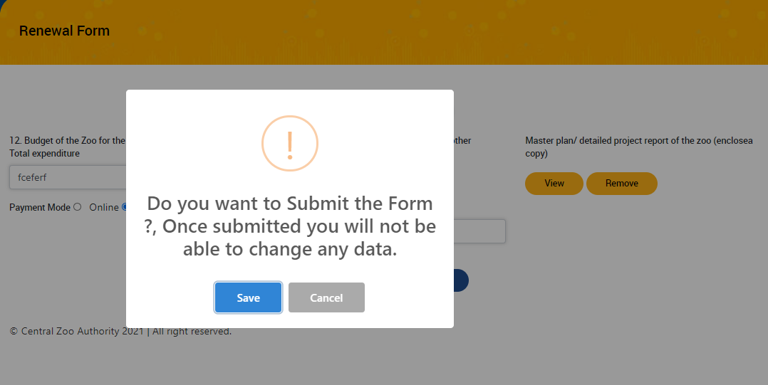

- If click on Save then information will not be changed in future.
- Confirmation message will display as shown below:

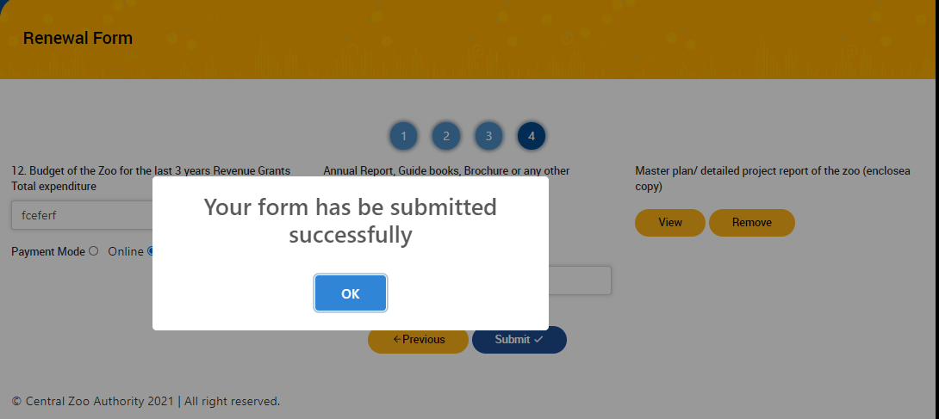

- After clicking on OK button, a reference number will get generated as shown below:

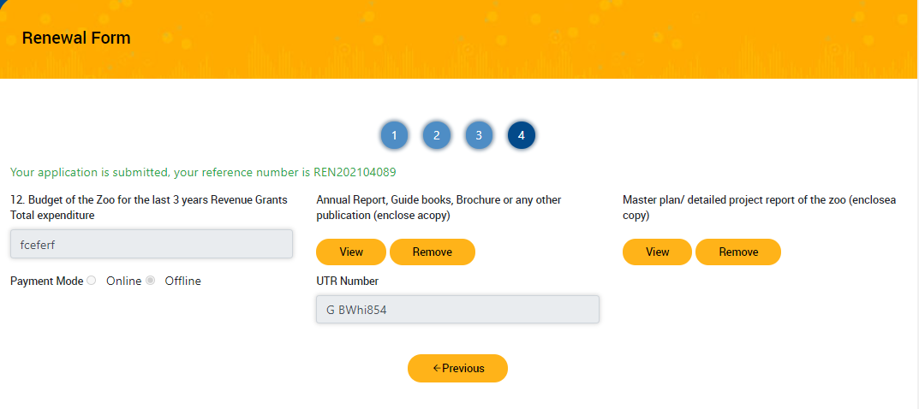

Assign for Evaluation
After clicking on Assign for Evaluation link from left navigation bar, following screen will display as shown below:

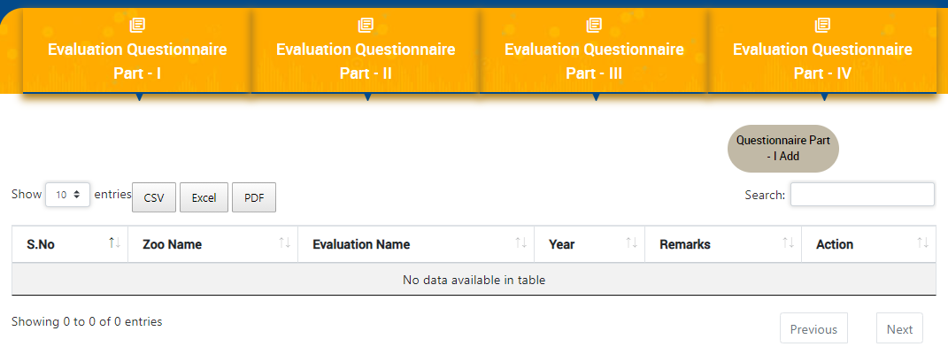

- Click on Questionnaire Part I, following screen will display as shown below:

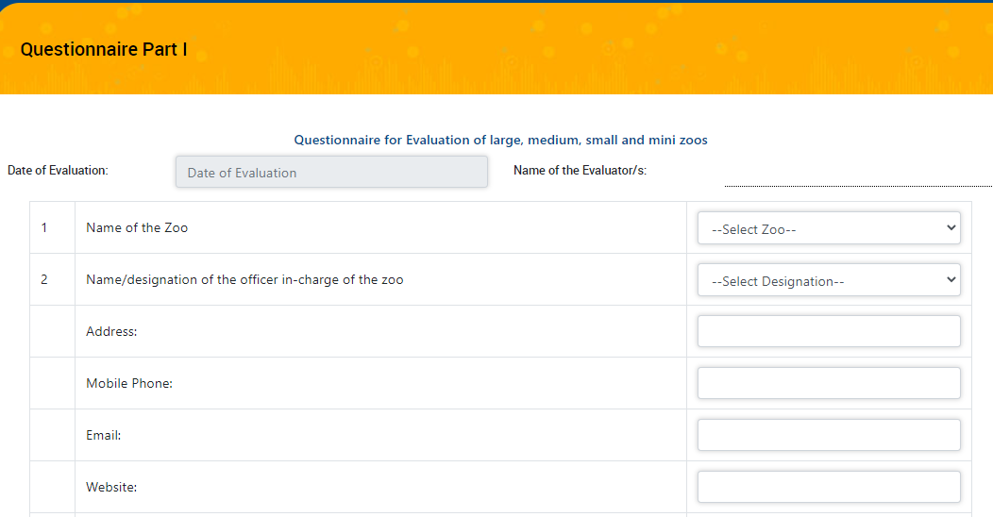
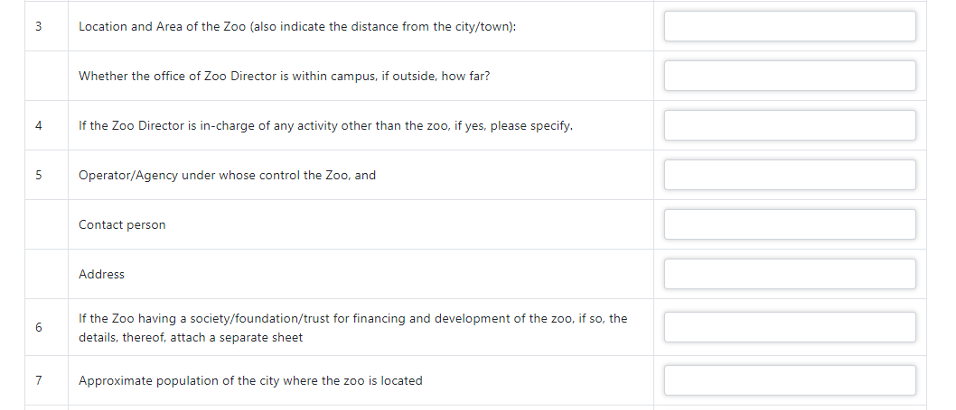
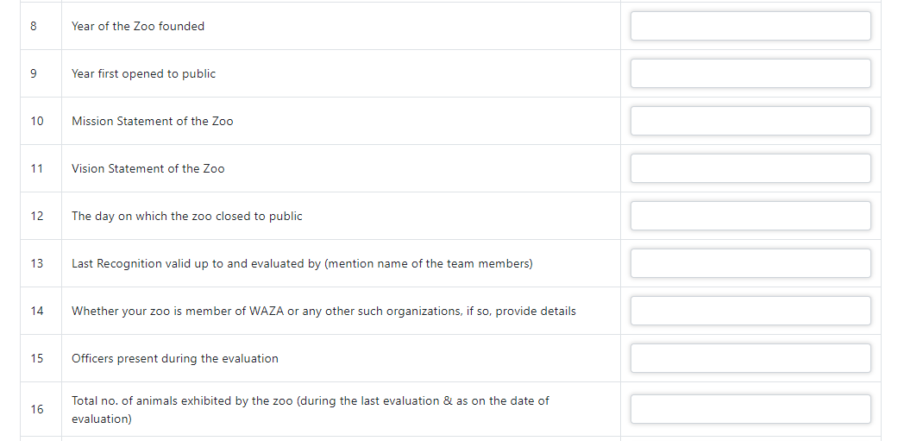
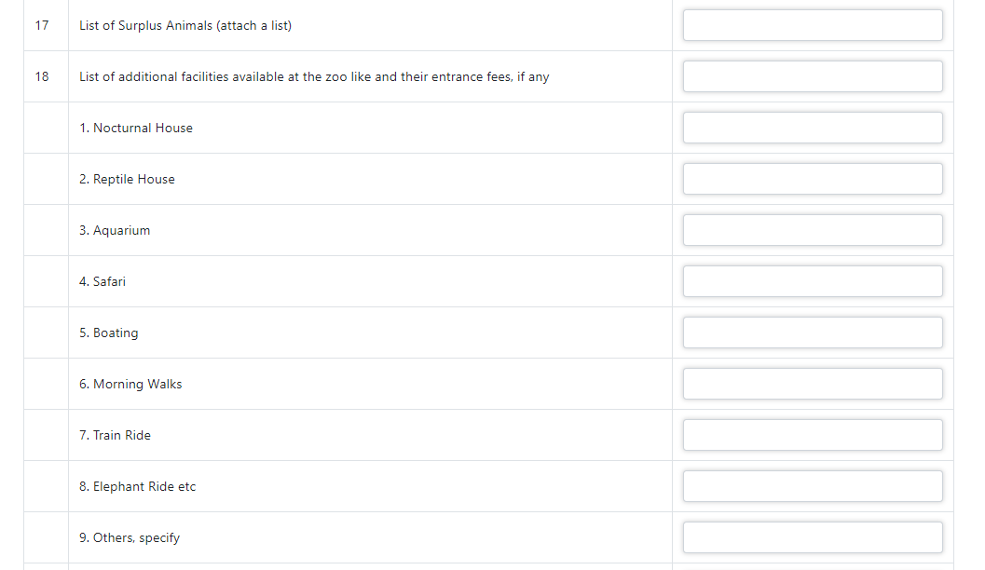
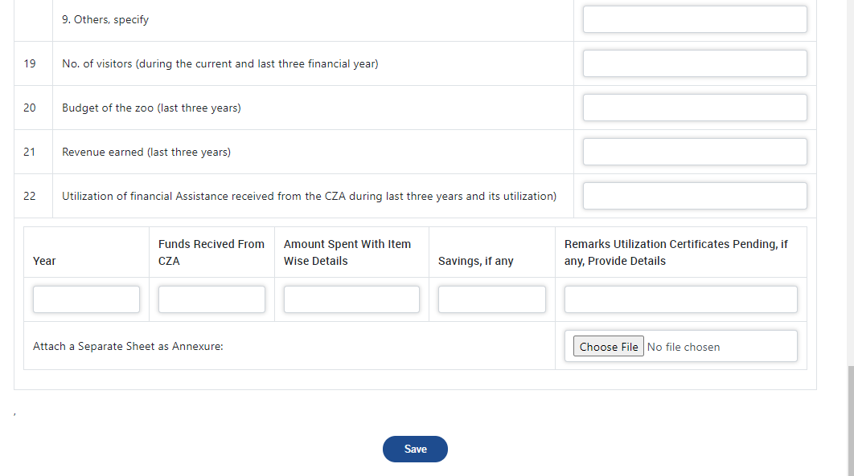

- Fill all required details and click on Save button
- To fill Questionnaire Part II , click on related button. Following screen will display as shown below:

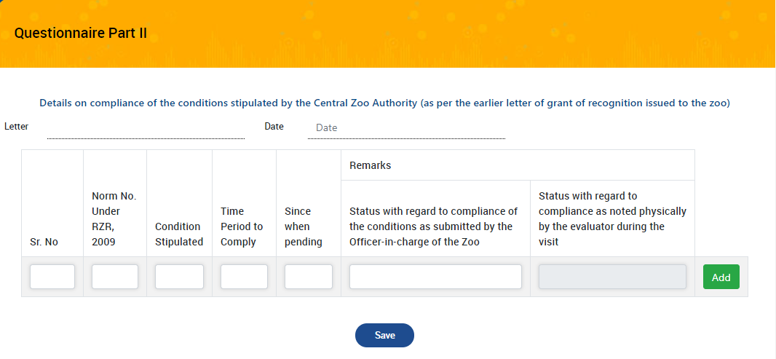

- Fill all required details and click on Save button
- To fill Questionnaire Part III , click on related button. Following screen will display as shown below:

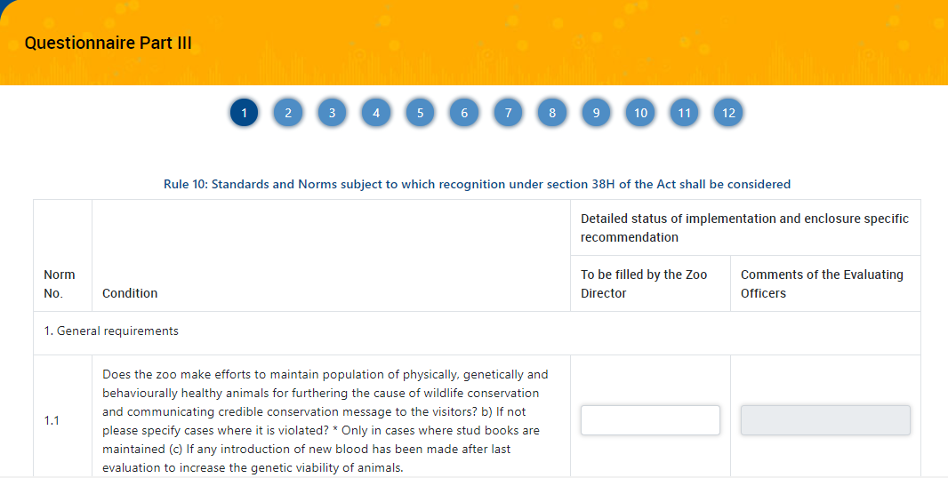

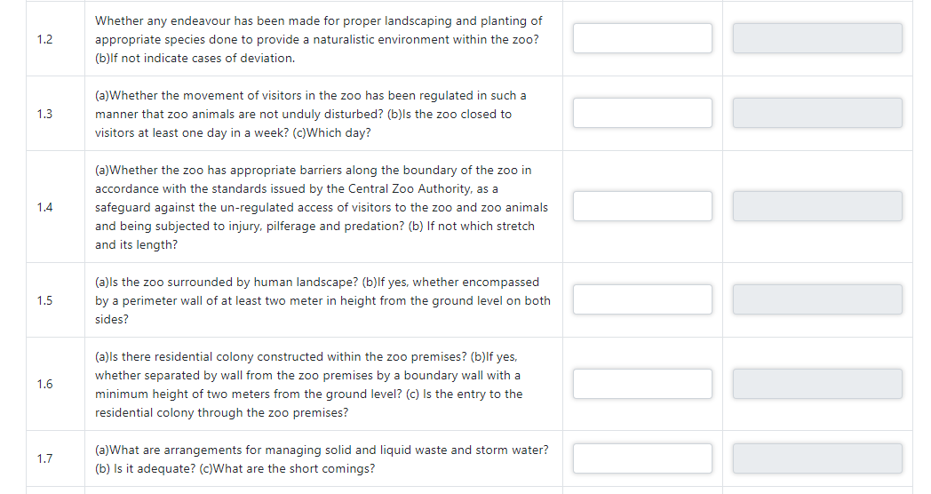
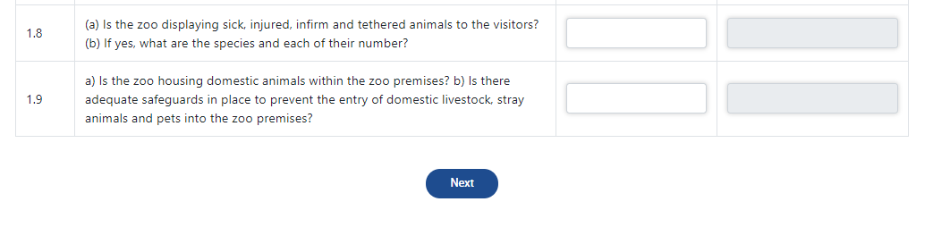

Master Plan
- To create master plan, click on Create link as shown below:

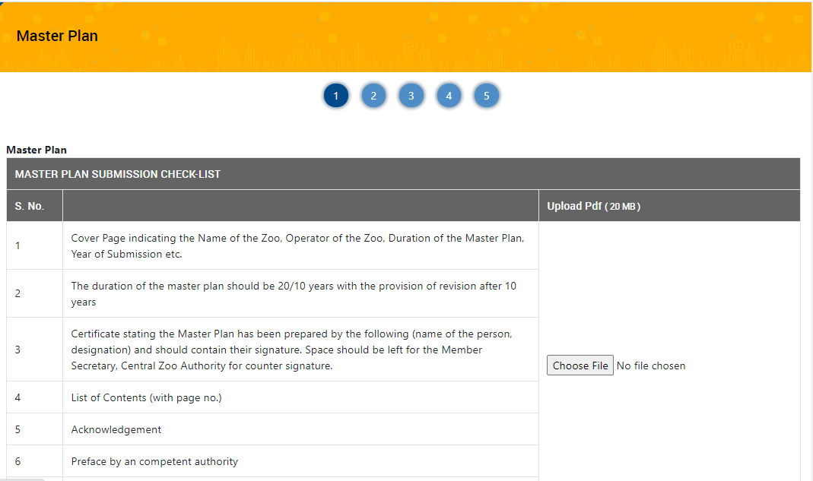
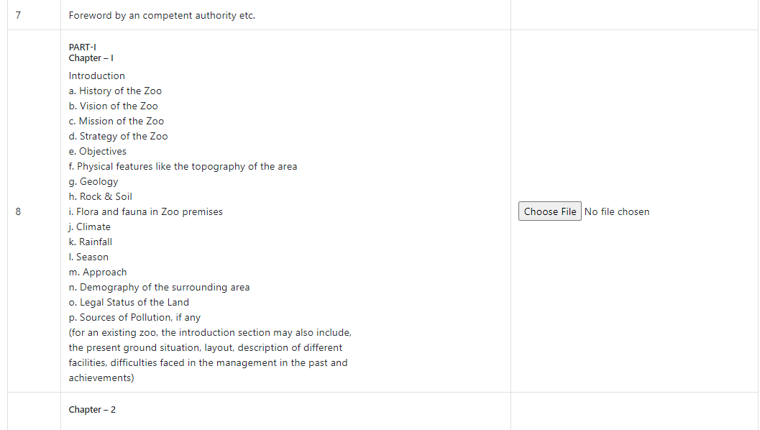

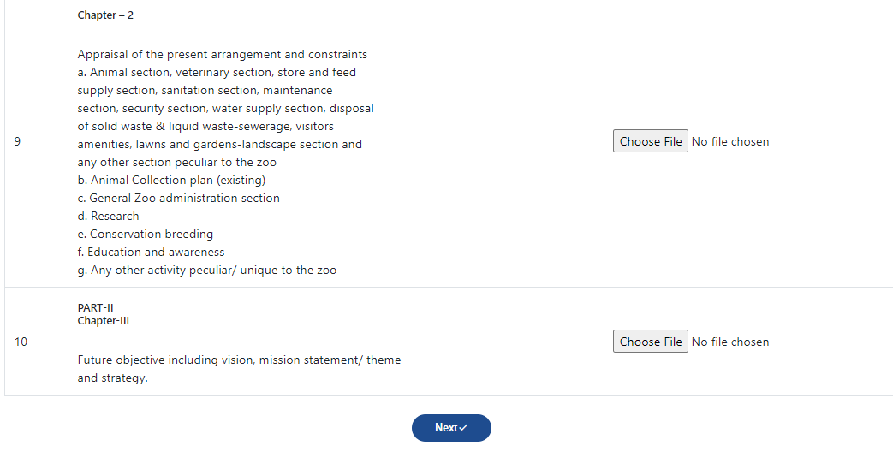

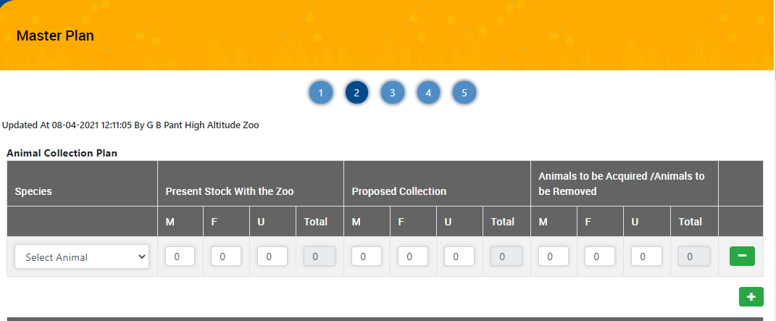

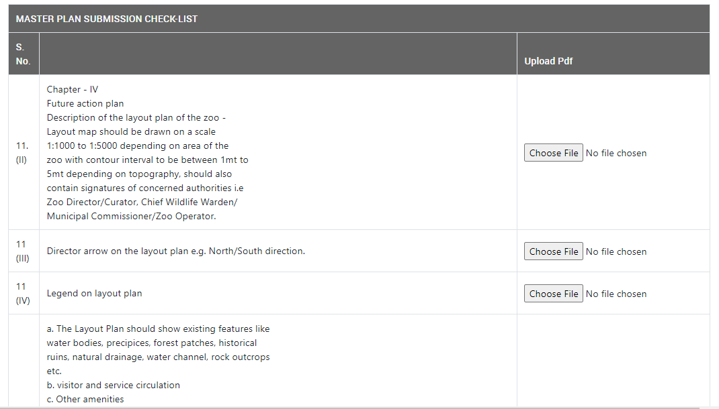

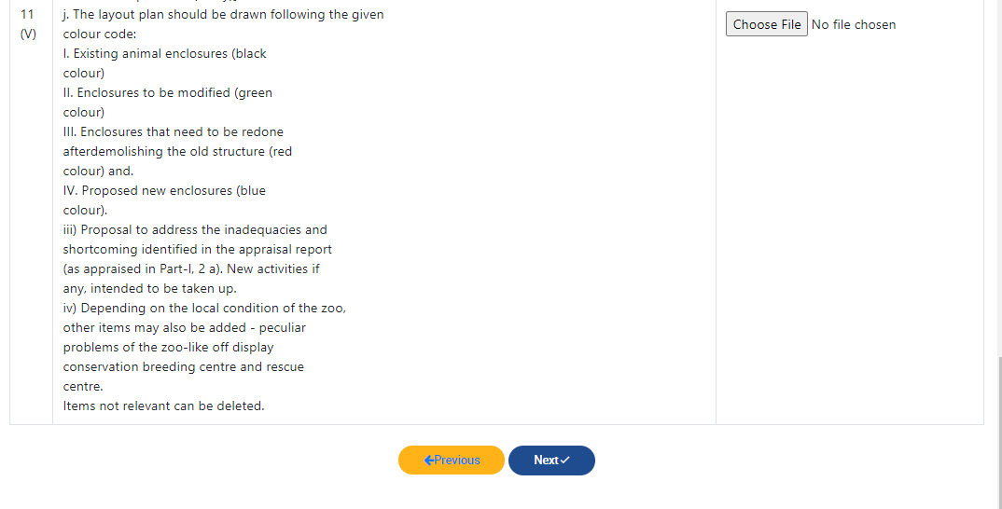

- Fill all details and click on Next button.
- Control will move on Step 3, as shown below

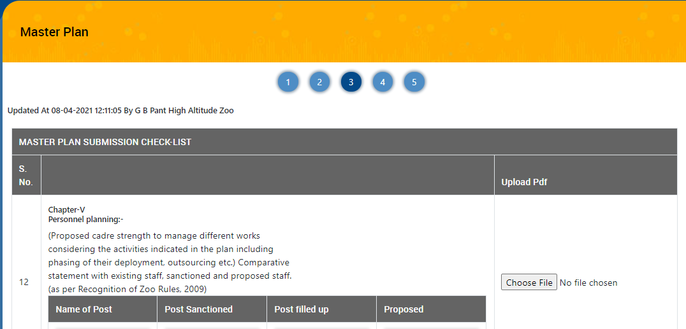
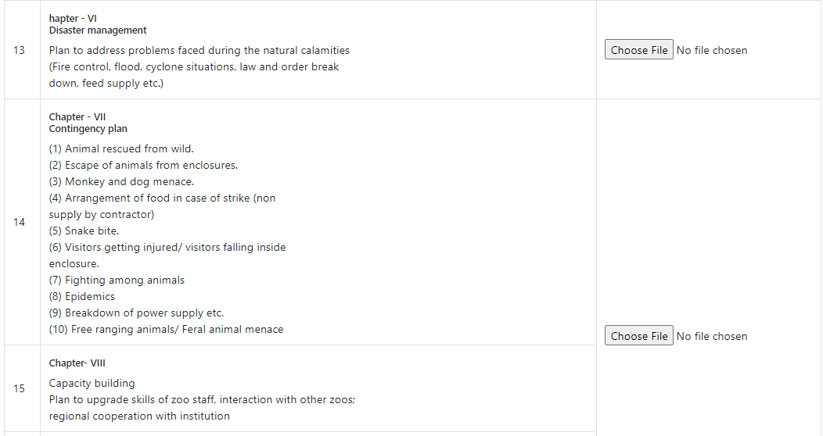
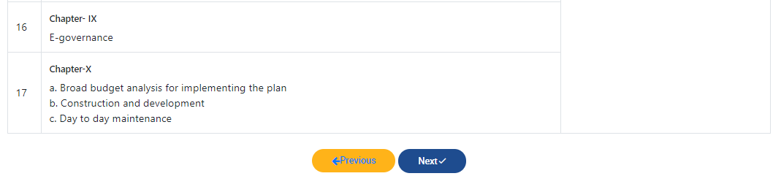

- Fill all details and click on Next button
- Similarly complete all steps and reach at final submission as shown below:

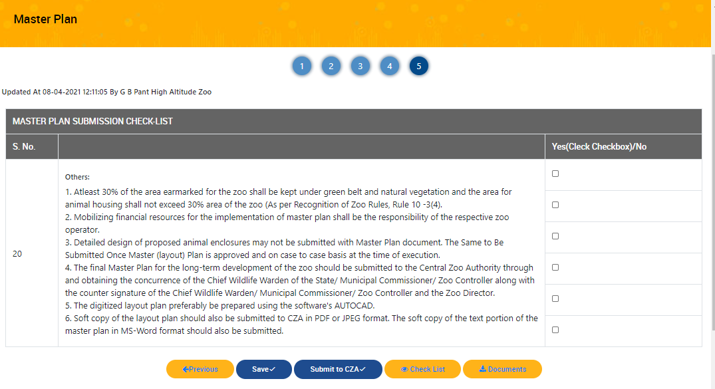

- Click on Submit to CZA button for final submission

Enclosure Drawing
- To create enclosure drawing, click on Create link as shown below:

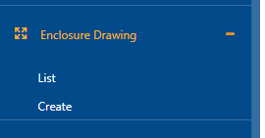

- Following screen will appear on Create link

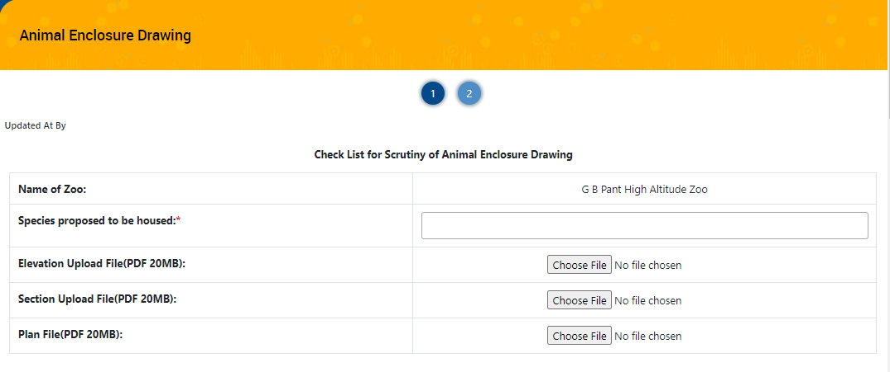
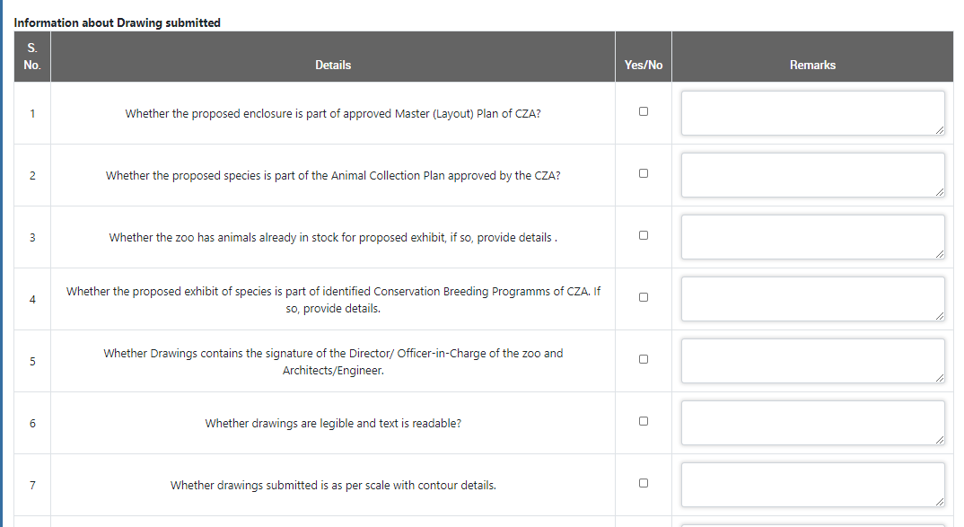
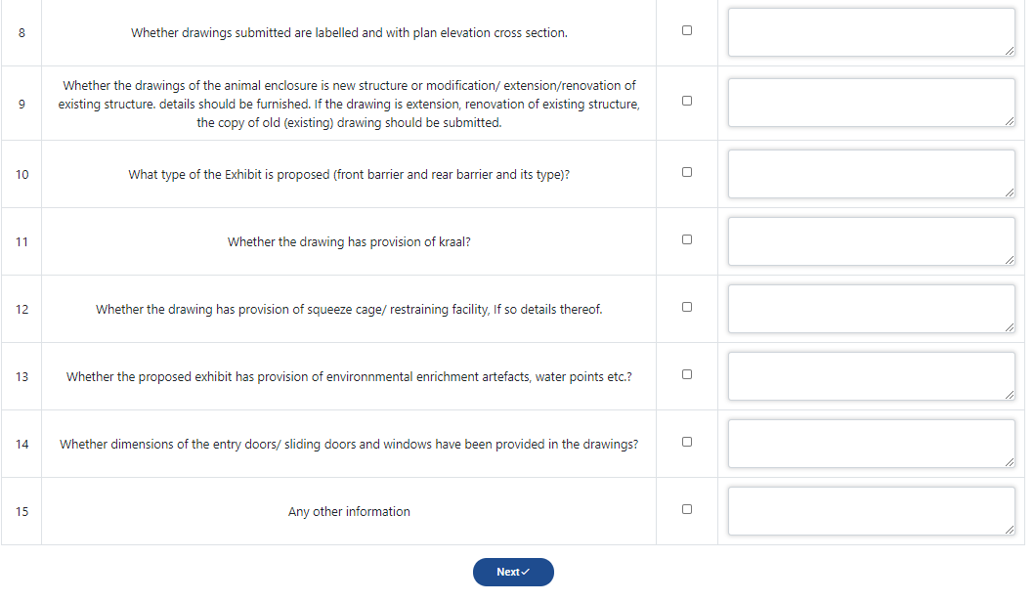

- Click on Next button after filling the details , following screen will be displayed as shown below:

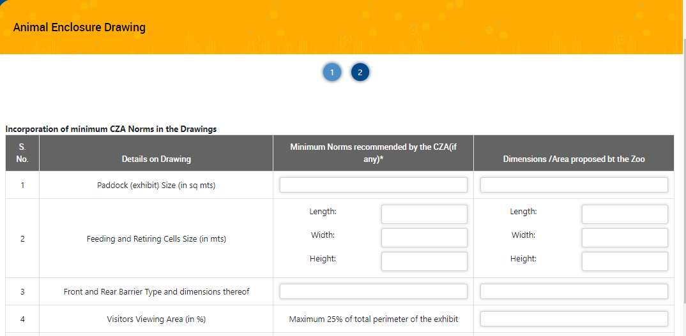

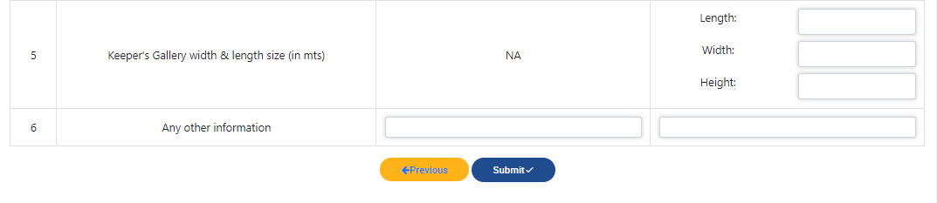
- Fill details and click on Submit button
- All saved data, will get saved in list table as shown below:

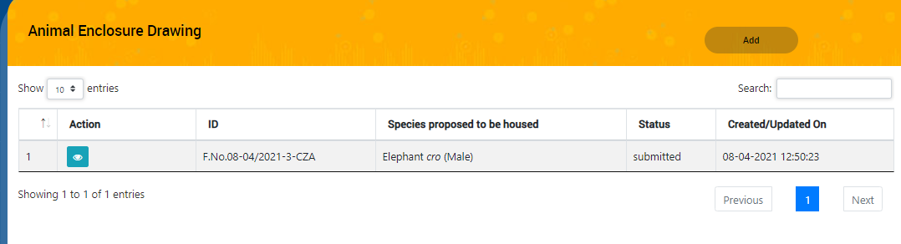

Exchange of Animals

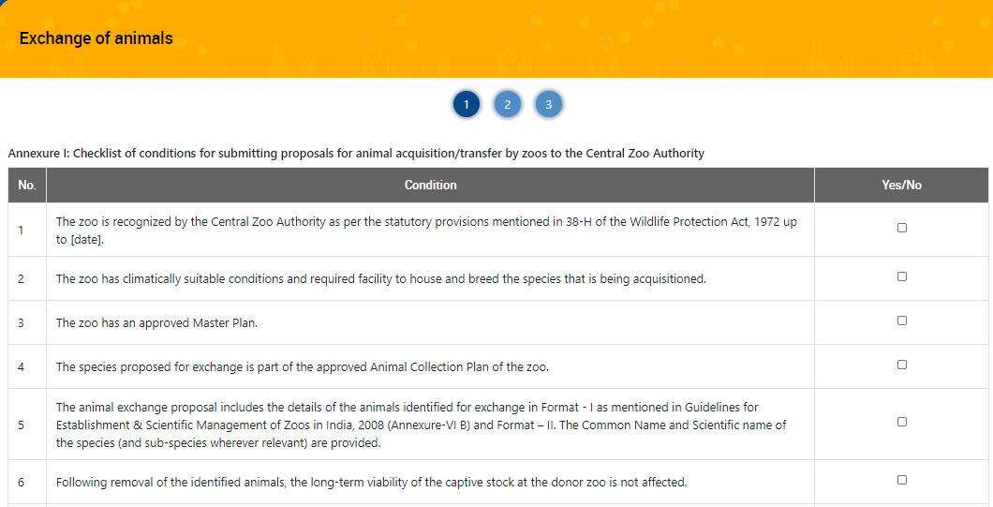
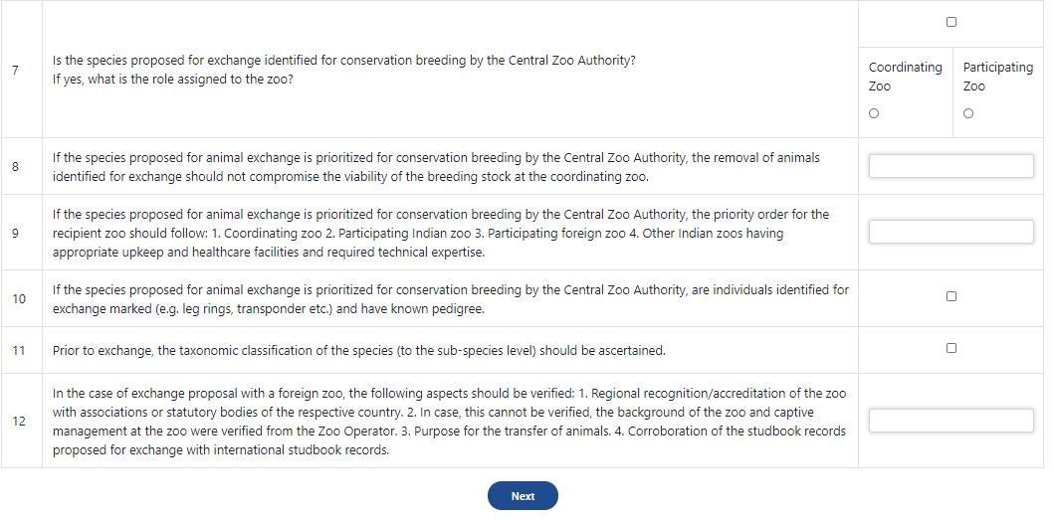

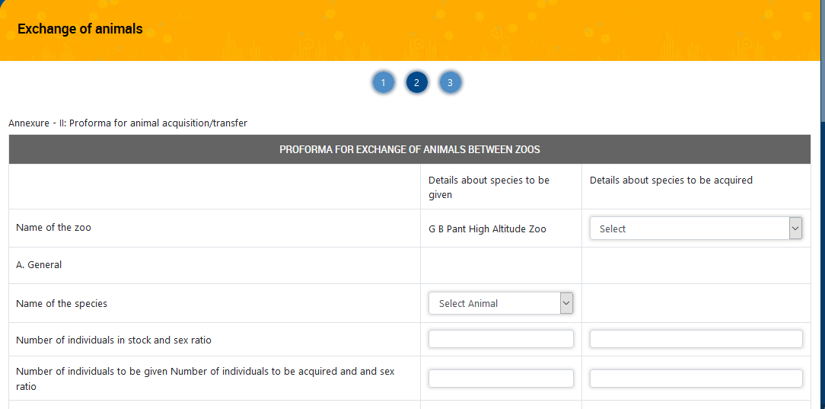
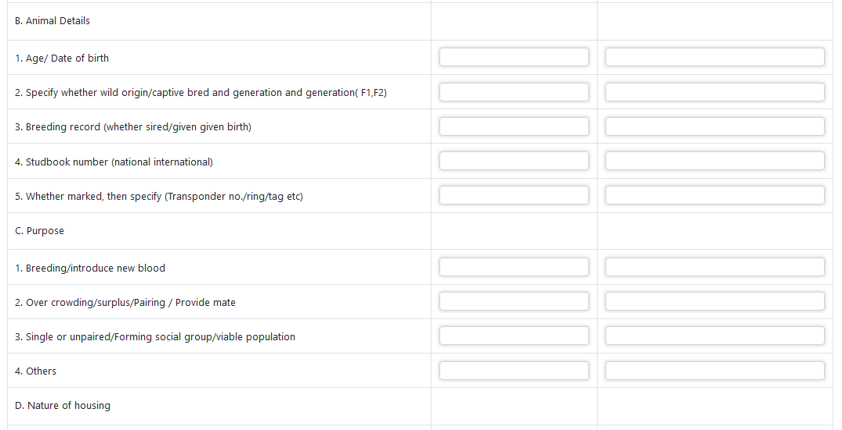
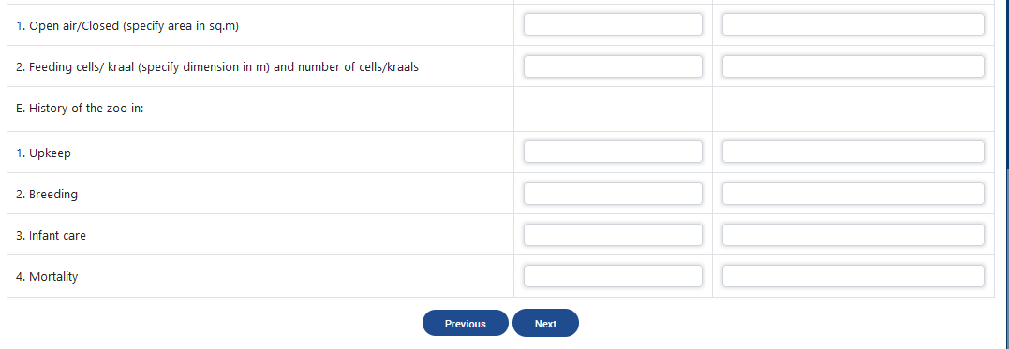
- Fill all details and click on Next button

Zoo Activity
To fill Zoo Activity, click on create link. Following screen will be displayed
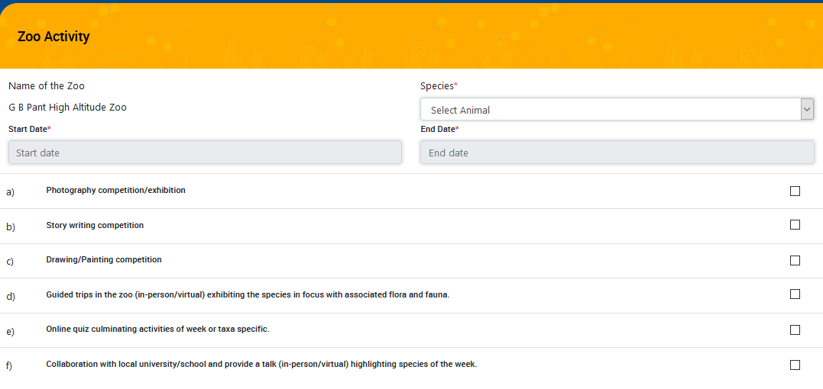
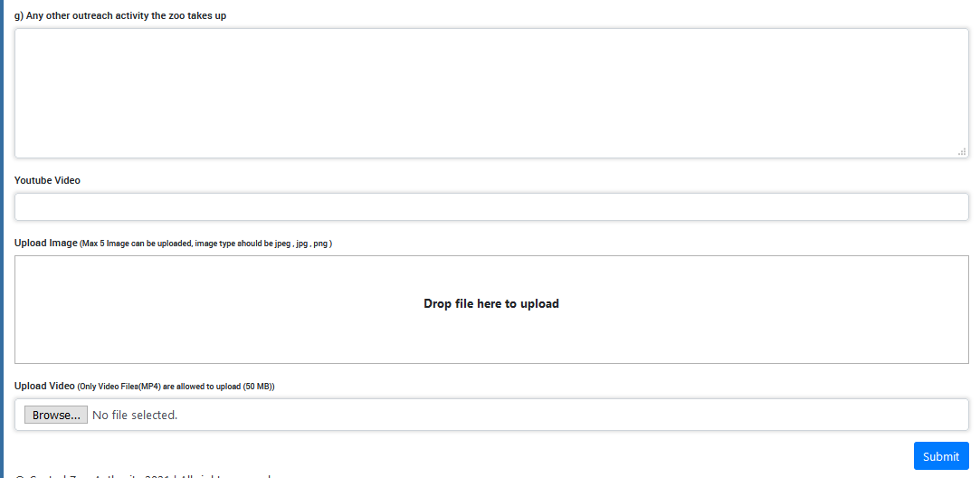
- Fill all details and click on Submit button
- Saved Details will be displayed in List as shown in screen below:

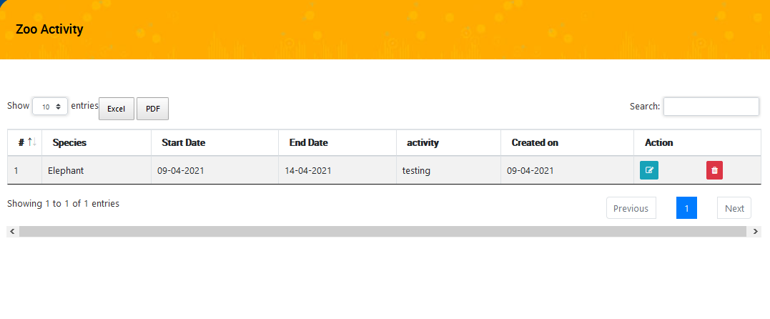

- Here user can edit or delete the record by clicking on Edit /Delete buttons.
- User can export data either in Excel or PDF format.

Zoo Information
- Click on Zoo Information, Zoo Profile screen will display in edit mode as shown below:
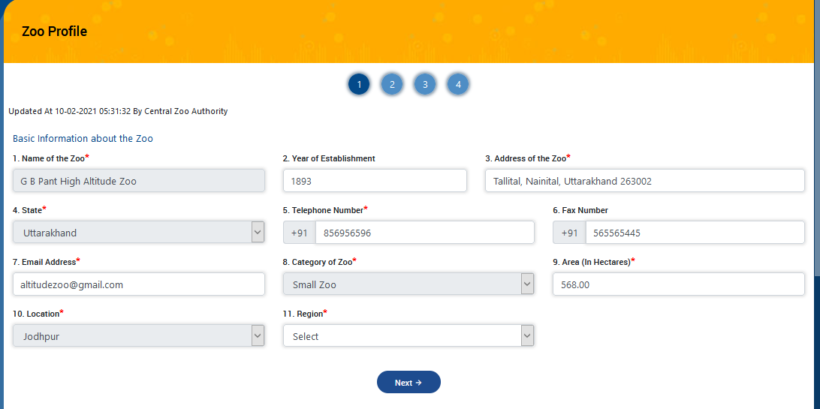
- Edit the enable fields then click on Next button
- Control will move on step 2 as shown in screen below:

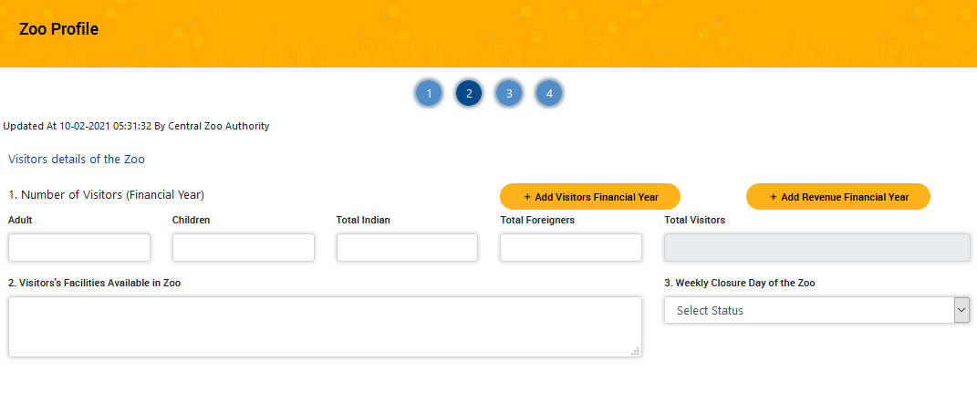
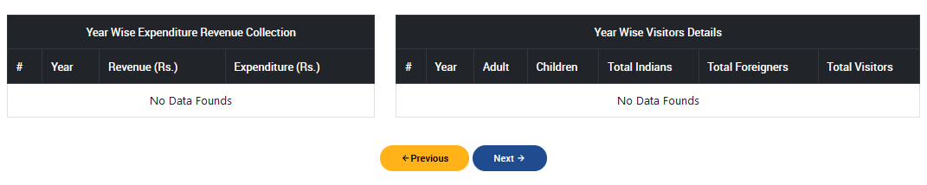
- Fill the Visitors details
note : Zoo Profile can be managed by the zoo itself, Zoo admin can add, update the details of zoo as permitted by super admin and when required.

- In above screen, there are two options available to add ‘Visitors Financial year’ and ‘Revenue Financial Year’.
- Click on Add Visitors Financial Year, following popup window will get opened as shown in screen below:

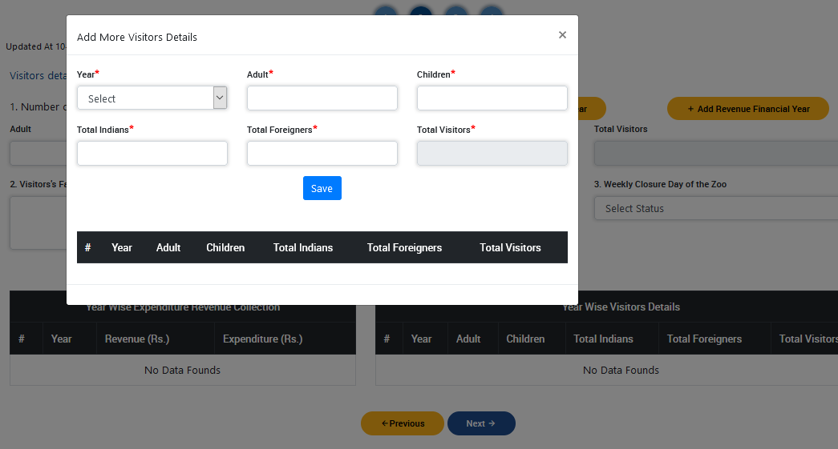
- To add financial revenue details, click on ‘Add Revenue Financial Year’ button , following popup window will get opened as shown in screen below:

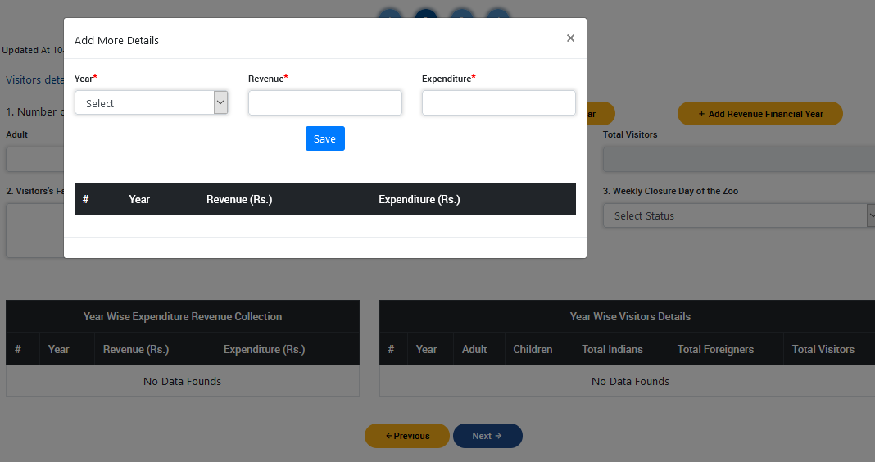
- Click on Next button, Management Personal detail page will displayed as shown in screen below:
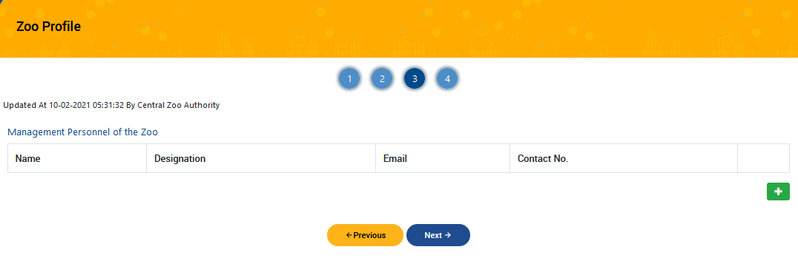
- After filling management details,click on Next button, Zoo Operator detail page will displayed as shown in screen below:

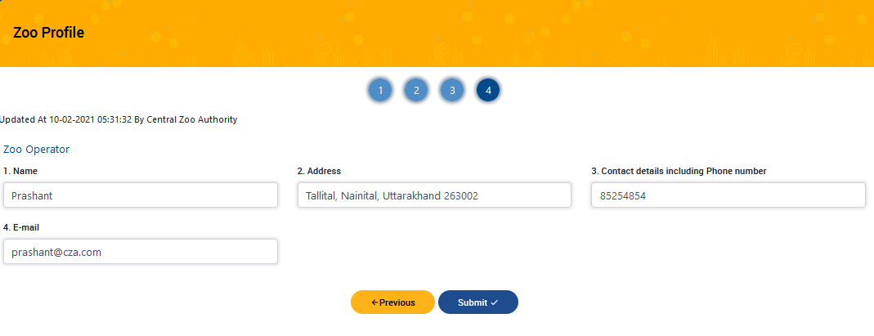

- Fill the Zoo Operator details and submit the form

Add Revenue and Expenditure
- To add revenue and expenditure , click on ‘Add Revenue and Expenditure’ link from left navigation bar.

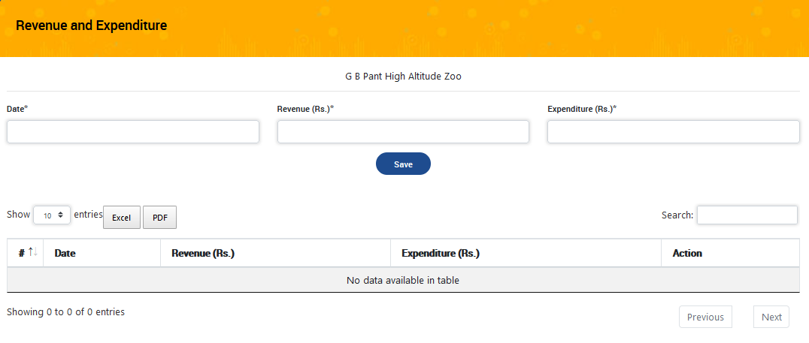

- Enter details and click on save button.
- Saved data will be displayed in table

User Management
- To add new users , click on Users link then following screen will be displayed

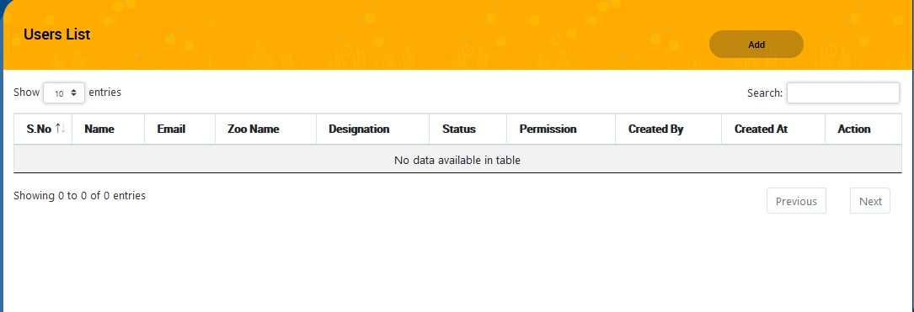

- Click on Add button, following screen will be displayed as shown below:

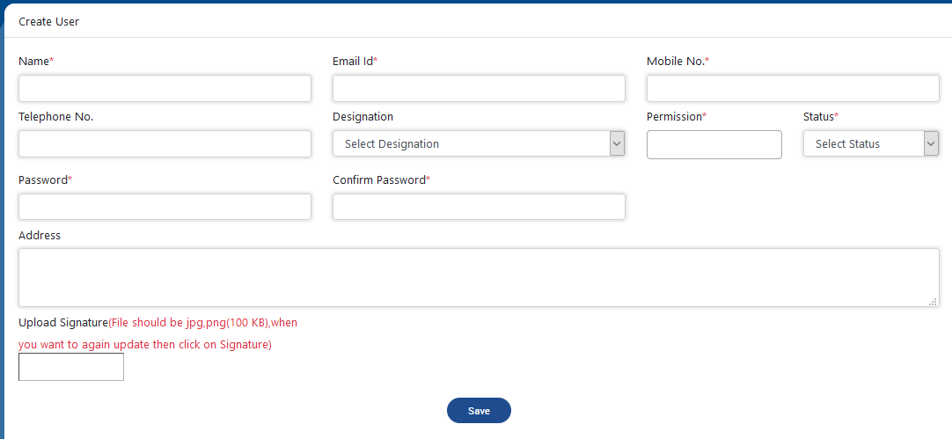

- Enter Name
- Enter Email Id
- Enter Mobile number
- Enter Telephone number
- Select Designation
- Select Permission
- Select Status
- Reset Password
- Upload Signature
- Click on Save button

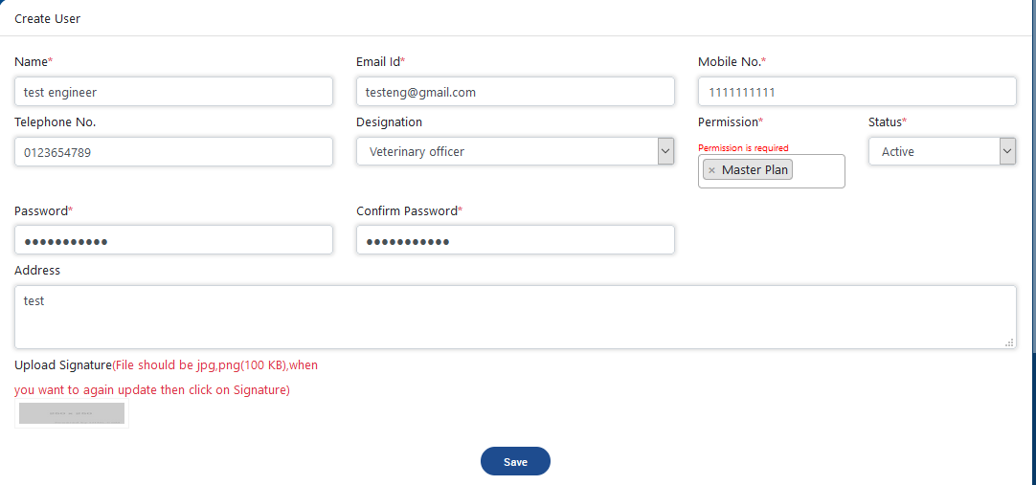

- Saved data will be displayed in table

Establishment Form
- Establishment Form link is available on login form. To add establishment detail click on the link, following form will be displayed as shown below:
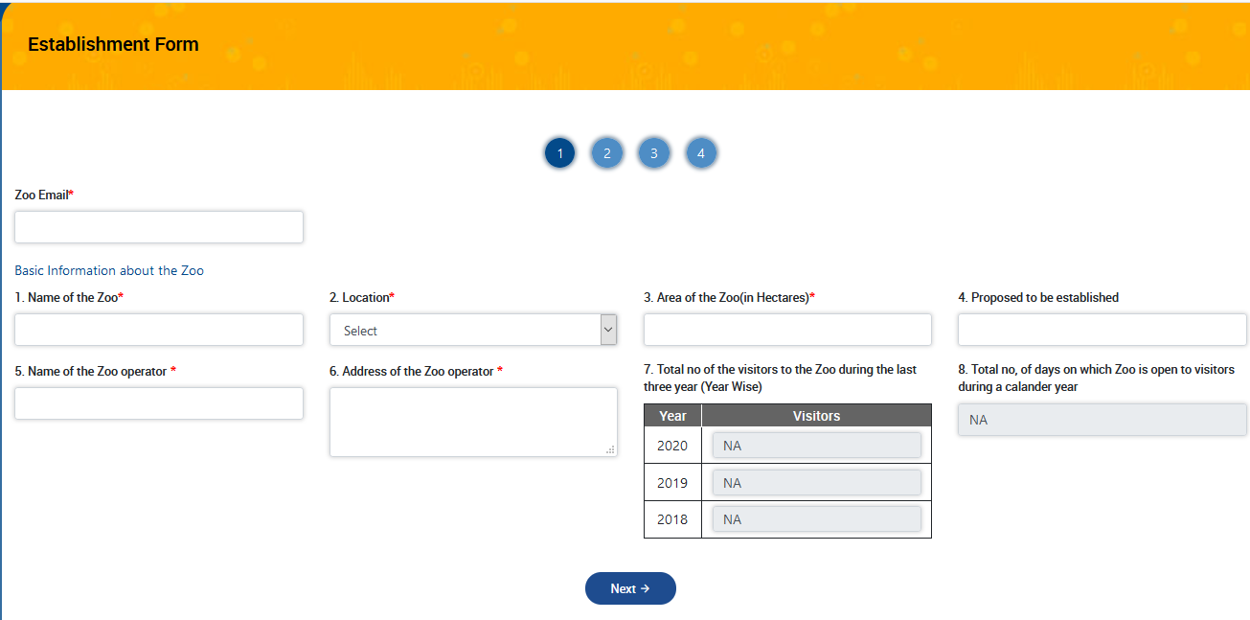

- Fill all details and click on Next button
- After clicking on Next button, control will be moved on second step as shown in screen below:

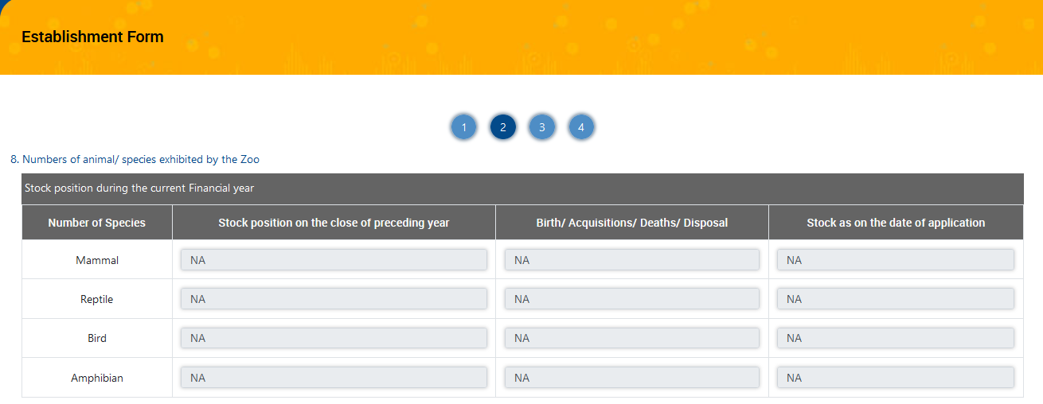
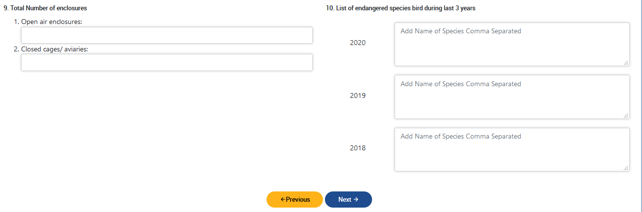

- Fill all details and click on Next button
- After clicking on Next button, control will be moved on third step as shown in screen below:

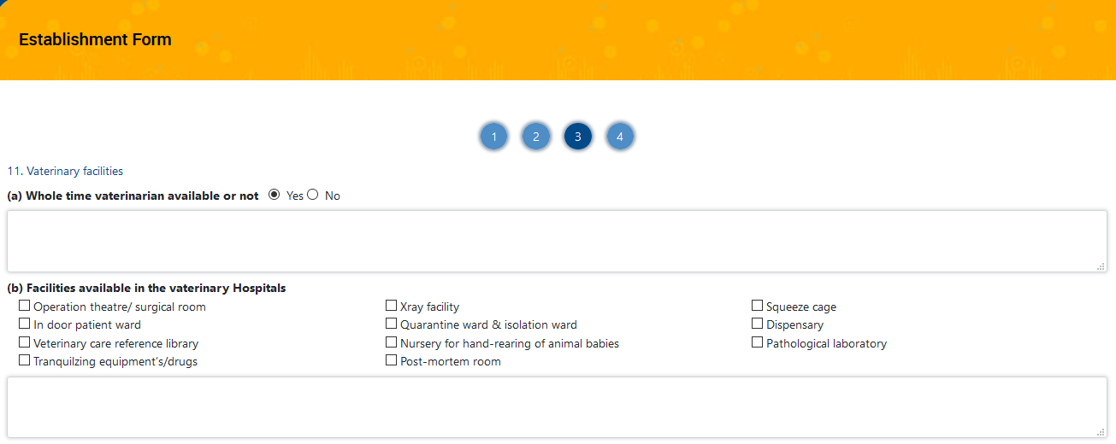
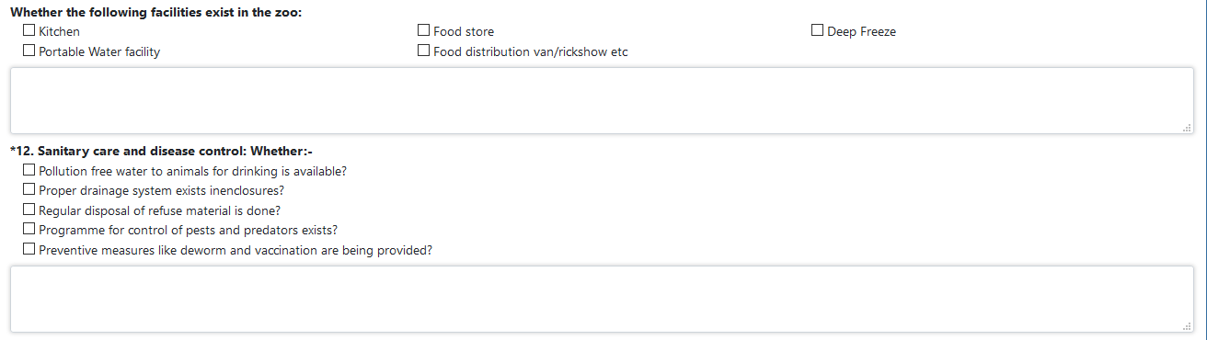
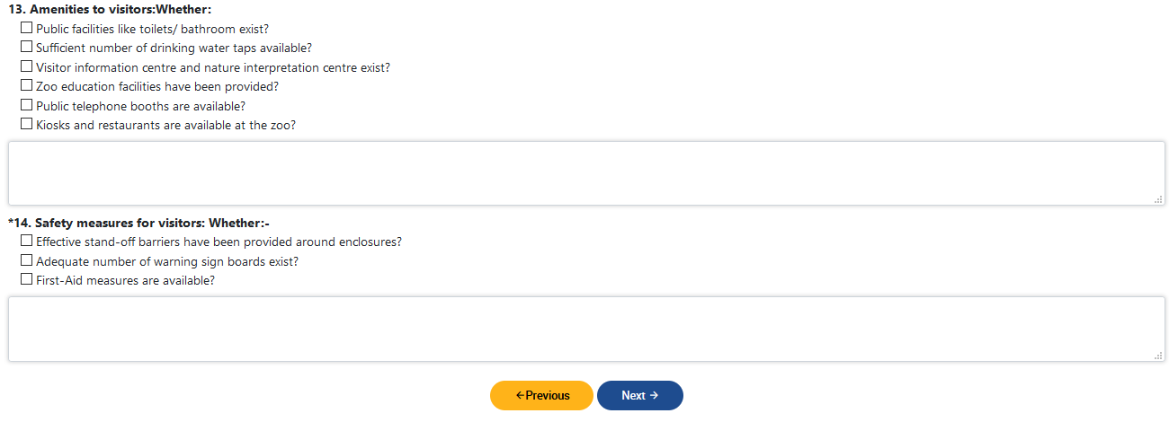

- Fill all details and click on Next button
- After clicking on Next button, control will be moved on fourth step as shown in screen below:

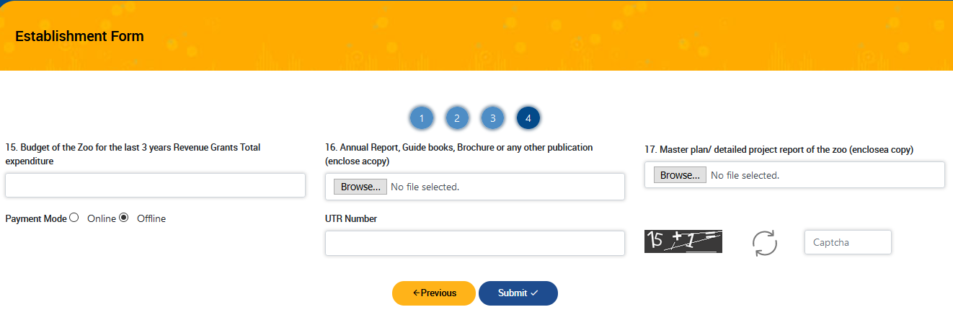

- Fill all details and click on Submit button
- After clicking on Submit button, a confirmation message alert popup will be displayed as shown in screen below:

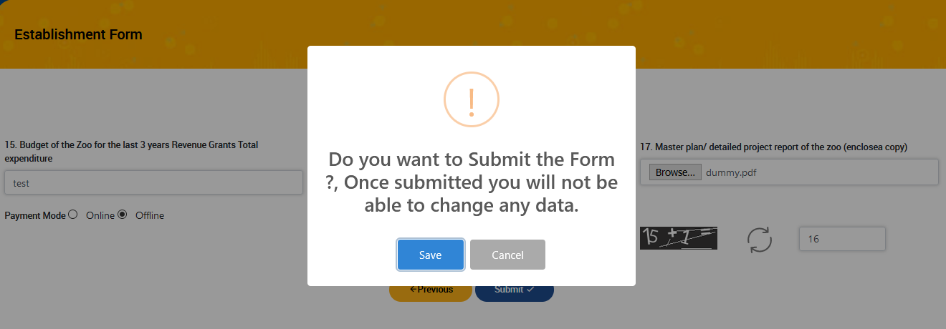

- If click on Save button then form will get submit and detail can’t be edit in future.

